Atchison SMA

Review of Investment Objectives &

Strategic Asset Allocation

September 2023

Table of Contents

1 Executive Summary 4

2 Review of Investment Strategies 9

2.1 Scenario Analysis Assumptions 9

2.2 The Most Volatile and the Least Volatile Portfolios 9

2.3 Analysis of Strategy: Active 20 10

2.4 Analysis of Strategy: Active 40 14

2.5 Analysis of Strategy: Active 55 18

2.6 Analysis of Strategy: Active 70 22

2.7 Analysis of Strategy: Active 85 26

2.8 Analysis of Strategy: Active 100 30

2.9 Scenario Stress Testing Summary 34

2.10 Environmental Stress Testing Summary 35

2.11 Liquidity Stress Testing Summary 35

3 Appendix A – Assumptions 36

3.1 Analysis of Asset Classes 36

3.2 Income/Capital Returns and Franking Assumption 36

4 Appendix B – Scenario & Enviromental Stress Testing 39

4.1 Background 39

4.2 Investment Option 39

4.3 Risk Factors 39

4.4 Methodology 40

4.5 Historical Analysis – Results 41

4.6 Forecast Analysis – Results 44

4.7 Trigger levels 46

5 Appendix C - Liquidity Stress Testing 47

5.1 Liquidity Profile 47

5.2 Liquidity Risk Management 60

# Executive Summary

Atchison Active SMA strategies have been developed to provide an implemented multi-asset solution.

A review the investment strategies provides recommendations on strategic asset allocation (SAA), expected return profile, time horizon, volatility, risk objective, alternate allocation optimisation, expected behaviour under stressed scenarios, and expected liquidity profiles.

Atchison will offer the choice of the following spectrum of diversified investment solutions. Refer to Table 1 below.

Table 1: Investment Options

|  |  |
| --- | --- |
| Investment Strategy | Growth/Defensive Allocations |
| Atchison Active 20 | 20.0% Growth assets / 80.0% Defensive assets |
| Atchison Active 40 | 40.0% Growth assets / 60.0% Defensive assets |
| Atchison Active 55 | 55.0% Growth assets / 45.0% Defensive assets |
| Atchison Active 70 | 70.0% Growth assets / 30.0% Defensive assets |
| Atchison Active 85 | 85.0% Growth assets / 15.0% Defensive assets |
| Atchison Active 100 | 99.0% Growth assets / 1.0% Defensive assets |

The scope of this review meets requirements for APRA regulated Superannuation Funds as per Prudential Standard 530 Investment Governance Guidelines and summarised in Table 2 below:

Table 2: The scope of this review

|  |  |  |  |  |  |  |  |
| --- | --- | --- | --- | --- | --- | --- | --- |
| Investment Strategy | SAA Review | SAA Ranges | Investment Objectives | Standard Risk Measure | Scenario Stress Testing | ESG/  Climate Stress Testing | Liquidity Stress Testing |
| Atchison Active 20 | ✓ | ✓ | ✓ | ✓ | ✓ | ✓ | ✓ |
| Atchison Active 40 | ✓ | ✓ | ✓ | ✓ | ✓ | ✓ | ✓ |
| Atchison Active 55 | ✓ | ✓ | ✓ | ✓ | ✓ | ✓ | ✓ |
| Atchison Active 70 | ✓ | ✓ | ✓ | ✓ | ✓ | ✓ | ✓ |
| Atchison Active 85 | ✓ | ✓ | ✓ | ✓ | ✓ | ✓ | ✓ |
| Atchison Active 100 | ✓ | ✓ | ✓ | ✓ | ✓ | ✓ | ✓ |

Review of Strategic Asset Allocation, Investment Objectives and Standard Risk Measures

Investment strategies have been analysed on a historical and forecast basis to ascertain whether the SAA, asset allocation ranges, investment objectives and standard risk measure (SRM) for the investment options remain suitable.

The review has included an assessment of how optimal the proposed asset allocation is against 100x Monte-Carlo randomised portfolio allocations selected within the asset class minimum and maximum constraints of the strategy. The below provides an extract of the Active 70 analysis visualised under the primary forecast scenario.

Detailed analysis of each investment strategy is provided within Section 2.

Recommendation

The following Tables 3 to 8 below provide a summary of recommendations regarding investment objectives, SAA, asset class ranges, and SRMs for each investment strategy:

Atchison Active 20

Table 3: Recommended Key Strategy Settings of Atchison Active 20

|  |  |  |
| --- | --- | --- |
| Strategic Asset Allocation (%) | Recommended SAA(%) | Ranges(%) |
| Growth Asset Allocation (%) | 20.0 | 10.0-30.0 |

|  |  |  |
| --- | --- | --- |
| Asset Class | Recommended SAA(%) | Ranges(%) |
| Australian Shares | 7.5 | 5.0-15.0 |
| International Shares | 7.5 | 5.0-15.0 |
| Real Assets | 2.5 | 0.0-10.0 |
| Alternatives | 2.5 | 0.0-10.0 |
| Long Duration | 40.0 | 20.0-60.0 |
| Floating Rate | 25.0 | 10.0-35.0 |
| Cash | 15.0 | 5.0-30.0 |
| **Investment Objective** | **CPI + 0.5% pa over rolling 3-year periods** | |
| **Standard Risk Measure** | **Medium** | |

Atchison Active 40

Table 4: Recommended Key Strategy Settings of Atchison Active 40

|  |  |  |  |
| --- | --- | --- | --- |
| Strategic Asset Allocation (%) | Recommended SAA(%) | | Ranges(%) |
| Growth Asset Allocation (%) | 40.0 | 30.0-50.0 | |

|  |  |  |
| --- | --- | --- |
| Asset Class | Recommended SAA(%) | Ranges(%) |
| Australian Shares | 15.0 | 5.0-30.0 |
| International Shares | 15.0 | 5.0-30.0 |
| Real Assets | 5.0 | 0.0-10.0 |
| Alternatives | 5.0 | 2.0-10.0 |
| Long Duration | 30.0 | 15.0-50.0 |
| Floating Rate | 20.0 | 10.0-35.0 |
| Cash | 10.0 | 5.0-25.0 |
| **Investment Objective** | **CPI + 1.0% pa over rolling 5-year periods** | |
| **Standard Risk Measure** | **Medium to High** | |

Atchison Active 55

Table 5: Recommended Key Strategy Settings of Atchison Active 55

|  |  |  |  |
| --- | --- | --- | --- |
| Strategic Asset Allocation (%) | Recommended SAA(%) | | Ranges(%) |
| Growth Asset Allocation (%) | 55.0 | 45.0-65.0 | |

|  |  |  |
| --- | --- | --- |
| Asset Class | Recommended SAA(%) | Ranges(%) |
| Australian Shares | 18.0 | 10.0-40.0 |
| International Shares | 17.0 | 10.0-40.0 |
| Real Assets | 10.0 | 0.0-15.0 |
| Alternatives | 10.0 | 2.0-15.0 |
| Long Duration | 22.5 | 5.0-45.0 |
| Floating Rate | 17.5 | 5.0-35.0 |
| Cash | 5.0 | 5.0-20.0 |
| **Investment Objective** | **CPI + 2.0% pa over rolling 7-year periods** | |
| **Standard Risk Measure** | **High** | |

Atchison Active 70

Table 6: Recommended Key Strategy Settings of Atchison Active 70

|  |  |  |  |
| --- | --- | --- | --- |
| Strategic Asset Allocation (%) | Recommended SAA(%) | | Ranges(%) |
| Growth Asset Allocation (%) | 70.0 | 60.0-80.0 | |

|  |  |  |
| --- | --- | --- |
| Asset Class | Recommended SAA(%) | Ranges(%) |
| Australian Shares | 22.5 | 18.0-35.0 |
| International Shares | 22.5 | 15.0-35.0 |
| Real Assets | 12.5 | 10.0-15.0 |
| Alternatives | 12.5 | 10.0-15.0 |
| Long Duration | 12.5 | 5.0-25.0 |
| Floating Rate | 12.5 | 2.0-20.0 |
| Cash | 5.0 | 2.0-10.0 |
| **Investment Objective** | **CPI + 3.0% pa over rolling 8-year periods** | |
| **Standard Risk Measure** | **High** | |

Atchison Active 85

Table 7: Recommended Key Strategy Settings of Atchison Active 85

|  |  |  |  |
| --- | --- | --- | --- |
| Strategic Asset Allocation (%) | Recommended SAA(%) | | Ranges(%) |
| Growth Asset Allocation (%) | 85.0 | 75.0-95.0 | |

|  |  |  |
| --- | --- | --- |
| Asset Class | Recommended SAA(%) | Ranges(%) |
| Australian Shares | 31.5 | 20.0-50.0 |
| International Shares | 31.5 | 20.0-55.0 |
| Real Assets | 8.0 | 0.0-10.0 |
| Alternatives | 14.0 | 2.0-25.0 |
| Long Duration | 7.0 | 0.0-15.0 |
| Floating Rate | 5.0 | 0.0-15.0 |
| Cash | 3.0 | 2.0-20.0 |
| **Investment Objective** | **CPI + 4.0% pa over rolling 10-year periods** | |
| **Standard Risk Measure** | **High** | |

Atchison Active 100

Table 8: Recommended Key Strategy Settings of Atchison Active 100

|  |  |  |  |
| --- | --- | --- | --- |
| Strategic Asset Allocation (%) | Recommended SAA(%) | | Ranges(%) |
| Growth Asset Allocation (%) | 99.0 | 90.0-100.0 | |

|  |  |  |
| --- | --- | --- |
| Asset Class | Recommended SAA(%) | Ranges(%) |
| Australian Shares | 40.0 | 25.0-55.0 |
| International Shares | 40.0 | 25.0-60.0 |
| Real Assets | 4.0 | 0.0-10.0 |
| Alternatives | 15.0 | 2.0-25.0 |
| Long Duration | 0.0 | 0.0-10.0 |
| Floating Rate | 0.0 | 0.0-10.0 |
| Cash | 1.0 | 0.5-10.0 |
| **Investment Objective** | **CPI + 5.0% pa over rolling 12-year periods** | |
| **Standard Risk Measure** | **High** | |

Conducting Scenario Stress Testing

Stress testing scenarios have been performed on Atchison strategies in accordance with APRA Prudential Standard SPS 530, factoring investment returns, SAA, and risk factors that have the potential to influence major asset classes and therefore have an impact on the investment performance of the investment strategy.

Conclusion

* A probability of greater than 50% is sought for an investment objective to be considered adequate. The Atchison strategies would have achieved its investment objective more than 50% of the time.
* The recommended risk disclosures for all multi-asset investment options remain suitable
* The investment option ranges have been stress tested by the addition of the most volatile portfolio (P1) and the least volatile portfolio (P2) for each investment option

Recommendation

As a result of this review, the trigger level has been derived as a pre-emptive flag to be monitored as part of the ongoing supervision of the investment strategy included in Appendix B.

On a quarterly basis, the performance of the investment options is to be monitored against their trigger levels to ensure that the options maintain at least a 50% probability to achieve their respective investment objectives.

Conducting ESG Stress Testing

An RSE licensee is required to consider the environmental (ESG) impacts of investments when formulating and implementing an investment strategy. APRA CPG 229 provides guidance on APRA’s view of sound practice in particular areas in relation to prudent practices to climate change financial risk management.

Given the unique nature and asset allocations, the approach taken by the asset consultant to managing environmental risk is to test the Atchison multi-asset investment portfolios expected investment performance through various significant historical environmental disasters. Refer to Appendix B.

Conclusion

* None of the environment disasters was a significant contributor (either negative or positive) to portfolio returns, likely due to the slow impact of climate change on asset class returns and the ability to take corrective actions as and when detrimental disasters etc. occur

Recommendation

* ESG stress testing to be performed annually

Conducting Liquidity Stress Testing

The SIS Act requires an RSE licensee to consider the liquidity of investments when formulating and implementing an investment strategy, while also considering the expected cash flow requirements of the RSE.

The Atchison Administrator reports contribution flows and member exits/outflows to the Trustee and investment manager to assist in the early identification of unusual patterns.

In managing liquidity risk the following matters may be included:

* Cash flow projections and past cash flow will be prepared on a regular basis to check the liquidity level needed
* Whether there are appropriate early warning indicators of liquidity risk for the single investment of Atchison, and
* Reporting to the Research and Investment Team, Trustee Investment Committee and Board.

Conclusion

* Consideration has been given to the liquidity of the underlying investments in normal and stressed market conditions for Atchison. The asset allocation is expected to remain liquid under stressed market scenarios.

Recommendation

* It is recommended that cash flow requirements are closely monitored to ensure sufficient cash is available to meet liabilities as they arise

# Review of Investment Strategies

A review of the current investment strategy and policy has been conducted. The investment objective, asset allocation and risk labels have been examined.

## Scenario Analysis Assumptions

Scenario analysis, on a forecast and historical basis, of annual portfolio returns and volatility of returns, growth/defensive asset allocation and probability of a negative return for Atchison has been undertaken and analysis is presented in Table 10.

Scenarios will be applied across the investment strategies based on the condition as detailed in Table 10.

Table 10: Scenarios settings

|  |  |  |
| --- | --- | --- |
| Category | Scenario 1 | Scenario 2 |
| Date Type | Before management fees and tax | Before management fees and tax |
| Confidence Level | 95.0% | 95.0% |
| Return and Volatility | Historical 30-year | Forecast 10-year |
| Correlation and methods | Historical 30-year | Historical 5-year, using Covariance Matrix |

Value at risk measures the largest loss likely to be incurred over one year with a confidence level (varies upon scenarios). Standard Risk Measure, as per the FSC/AFSA guidelines has been derived for each investment option.

## The Most Volatile and the Least Volatile Portfolios

Atchison Consultants has utilised a proxy approach for testing SAA ranges to generate:

* the most volatile portfolio for each investment option, denoted as P1. This portfolio has been structured to ensure that the allocation of assets conforms to the minimum range requirement for each asset class and growth-defensive constraints, while concurrently allocating the maximum range value to the most volatile asset classes.
* the least volatile portfolio for each investment option, denoted as P2. This portfolio has been structured to ensure that the allocation of assets conforms to the minimum range requirement for each asset class and growth-defensive constraints, while concurrently allocating the maximum range value to the least volatile asset classes.

The asset allocations and scenario analysis of P1 and P2 for each investment option are displayed in the following sections.

## Analysis of Strategy: Active 20

### Analysis of Asset Allocation

Table 11 tests and demonstrates the returns, volatility of returns and the probabilities of the current SAA meeting the current stated investment objective of CPI + 0.5% pa over 3-year periods, on a historical basis, before management fees and tax.

Table 11: Scenario 1 Historical Analysis – Strategic Asset Allocations

|  |  |  |  |
| --- | --- | --- | --- |
| Category | Current SAA | Most Volatile Portfolio P1 | Least Volatile Portfolio P2 |
| **Asset Classes** |  |  |  |
| Australian Shares(%) | 7.5 | 5.0 | 5.0 |
| International Shares(%) | 7.5 | 5.0 | 5.0 |
| Real Assets(%) | 2.5 | 10.0 | 0.0 |
| Alternatives(%) | 2.5 | 0.0 | 10.0 |
| Long Duration(%) | 40.0 | 40.0 | 40.0 |
| Floating Rate(%) | 25.0 | 35.0 | 10.0 |
| Cash(%) | 15.0 | 5.0 | 30.0 |
| **Total** | **100** | **100** | **100** |
| Growth(%) | 20.0 | 20.0 | 20.0 |
| Defensive(%) | 80.0 | 80.0 | 80.0 |
| **Scenario Analysis** |  |  |  |
| Return(%,p.a.) | 5.6 | 5.5 | 5.4 |
| Volatility(%,p.a.) | 3.1 | 3.4 | 2.4 |
| Sharpe | 0.45 | 0.36 | 0.50 |
| Risk Band | 2.0 | 3.0 | 1.0 |
| Risk Level | Low | Low to Medium | Very Low |
| **Probability of Achieving CPI-based Return Target** |  |  |  |
| CPI+0.5%p.a. over a 1-year rolling period(%) | 78.7 | 74.9 | 82.6 |
| CPI+1.0%p.a. over a 1-year rolling period(%) | 73.7 | 70.0 | 76.7 |
| CPI+1.5%p.a. over a 1-year rolling period(%) | 68.1 | 64.8 | 69.9 |
| CPI+2.0%p.a. over a 1-year rolling period(%) | 62.1 | 59.3 | 62.2 |
| CPI+2.5%p.a. over a 1-year rolling period(%) | 55.8 | 53.6 | 54.1 |
| CPI+0.5%p.a. over a 2-year rolling period(%) | 88.0 | 83.9 | 91.7 |
| CPI+1.0%p.a. over a 2-year rolling period(%) | 82.5 | 78.1 | 86.0 |
| CPI+1.5%p.a. over a 2-year rolling period(%) | 75.7 | 71.4 | 78.0 |
| CPI+2.0%p.a. over a 2-year rolling period(%) | 67.7 | 63.7 | 67.8 |
| CPI+2.5%p.a. over a 2-year rolling period(%) | 58.6 | 55.3 | 56.0 |
| CPI+0.5%p.a. over a 3-year rolling period(%) | 93.3 | 89.7 | 96.2 |
| CPI+1.0%p.a. over a 3-year rolling period(%) | 88.5 | 84.0 | 91.7 |
| CPI+1.5%p.a. over a 3-year rolling period(%) | 81.5 | 76.5 | 83.9 |
| CPI+2.0%p.a. over a 3-year rolling period(%) | 72.2 | 67.4 | 72.4 |
| CPI+2.5%p.a. over a 3-year rolling period(%) | 61.1 | 56.9 | 57.8 |
| CPI+0.5%p.a. over a 4-year rolling period(%) | 96.5 | 93.6 | 98.4 |
| CPI+1.0%p.a. over a 4-year rolling period(%) | 92.7 | 88.5 | 95.2 |
| CPI+1.5%p.a. over a 4-year rolling period(%) | 86.1 | 80.9 | 88.5 |
| CPI+2.0%p.a. over a 4-year rolling period(%) | 76.3 | 70.7 | 76.5 |
| CPI+2.5%p.a. over a 4-year rolling period(%) | 63.4 | 58.3 | 59.4 |
| CPI+0.5%p.a. over a 5-year rolling period(%) | 98.3 | 96.2 | 99.4 |
| CPI+1.0%p.a. over a 5-year rolling period(%) | 95.5 | 92.0 | 97.4 |
| CPI+1.5%p.a. over a 5-year rolling period(%) | 89.9 | 84.8 | 92.0 |
| CPI+2.0%p.a. over a 5-year rolling period(%) | 80.0 | 73.9 | 80.2 |
| CPI+2.5%p.a. over a 5-year rolling period(%) | 65.7 | 59.8 | 61.0 |
| **Annualised Value at Risk** |  |  |  |
| 1 in 20 year event(%) | 0 | -0.2 | 0 |
| **Frequency of Negative Annual Total Return** |  |  |  |
| Number of Negative Annual Return in any 20-year period | 0.7 | 1.1 | 0.2 |
| Probability of a Negative Annual Return(%) | 3.4 | 5.6 | 1.2 |

Table 12 tests and demonstrates the returns, volatility of returns and the probabilities of the current SAA meeting the current stated investment objective of CPI + 0.5% pa over 3-year periods, on a forecast basis, before management fees and tax.

Table 12: Scenario 2 Forecast Analysis – Strategic Asset Allocations

|  |  |  |  |
| --- | --- | --- | --- |
| Category | Current SAA | Most Volatile Portfolio P1 | Least Volatile Portfolio P2 |
| **Asset Classes** |  |  |  |
| Australian Shares(%) | 7.5 | 5.0 | 5.0 |
| International Shares(%) | 7.5 | 5.0 | 5.0 |
| Real Assets(%) | 2.5 | 10.0 | 0.0 |
| Alternatives(%) | 2.5 | 0.0 | 10.0 |
| Long Duration(%) | 40.0 | 40.0 | 40.0 |
| Floating Rate(%) | 25.0 | 35.0 | 10.0 |
| Cash(%) | 15.0 | 5.0 | 30.0 |
| **Total** | **100** | **100** | **100** |
| Growth(%) | 20.0 | 20.0 | 20.0 |
| Defensive(%) | 80.0 | 80.0 | 80.0 |
| **Scenario Analysis** |  |  |  |
| Return(%,p.a.) | 4.5 | 4.6 | 4.2 |
| Volatility(%,p.a.) | 4.2 | 4.9 | 3.2 |
| Sharpe | 0.43 | 0.37 | 0.44 |
| Risk Band | 4.0 | 5.0 | 3.0 |
| Risk Level | Medium | Medium to High | Low to Medium |
| **Probability of Achieving CPI-based Return Target** |  |  |  |
| CPI+0.5%p.a. over a 1-year rolling period(%) | 64.3 | 62.6 | 64.2 |
| CPI+1.0%p.a. over a 1-year rolling period(%) | 59.8 | 58.6 | 58.2 |
| CPI+1.5%p.a. over a 1-year rolling period(%) | 55.2 | 54.6 | 52.1 |
| CPI+2.0%p.a. over a 1-year rolling period(%) | 50.5 | 50.5 | 45.9 |
| CPI+2.5%p.a. over a 1-year rolling period(%) | 45.7 | 46.4 | 39.7 |
| CPI+0.5%p.a. over a 2-year rolling period(%) | 70.5 | 68.1 | 70.3 |
| CPI+1.0%p.a. over a 2-year rolling period(%) | 64.3 | 62.6 | 62.0 |
| CPI+1.5%p.a. over a 2-year rolling period(%) | 57.6 | 56.8 | 53.0 |
| CPI+2.0%p.a. over a 2-year rolling period(%) | 50.7 | 50.8 | 43.9 |
| CPI+2.5%p.a. over a 2-year rolling period(%) | 43.7 | 44.7 | 35.0 |
| CPI+0.5%p.a. over a 3-year rolling period(%) | 75.3 | 72.5 | 75.1 |
| CPI+1.0%p.a. over a 3-year rolling period(%) | 67.9 | 65.9 | 65.1 |
| CPI+1.5%p.a. over a 3-year rolling period(%) | 59.7 | 58.6 | 53.9 |
| CPI+2.0%p.a. over a 3-year rolling period(%) | 50.9 | 51.0 | 42.2 |
| CPI+2.5%p.a. over a 3-year rolling period(%) | 41.9 | 43.2 | 31.1 |
| CPI+0.5%p.a. over a 4-year rolling period(%) | 79.4 | 76.3 | 79.1 |
| CPI+1.0%p.a. over a 4-year rolling period(%) | 71.2 | 68.8 | 67.9 |
| CPI+1.5%p.a. over a 4-year rolling period(%) | 61.6 | 60.3 | 54.7 |
| CPI+2.0%p.a. over a 4-year rolling period(%) | 51.0 | 51.2 | 40.7 |
| CPI+2.5%p.a. over a 4-year rolling period(%) | 40.3 | 41.8 | 27.6 |
| CPI+0.5%p.a. over a 5-year rolling period(%) | 83.0 | 79.7 | 82.6 |
| CPI+1.0%p.a. over a 5-year rolling period(%) | 74.3 | 71.6 | 70.6 |
| CPI+1.5%p.a. over a 5-year rolling period(%) | 63.5 | 62.0 | 55.4 |
| CPI+2.0%p.a. over a 5-year rolling period(%) | 51.2 | 51.4 | 39.1 |
| CPI+2.5%p.a. over a 5-year rolling period(%) | 38.6 | 40.5 | 24.3 |
| **Annualised Value at Risk** |  |  |  |
| 1 in 20 year event(%) | -2.4 | -3.5 | -1.1 |
| **Frequency of Negative Annual Total Return** |  |  |  |
| Number of Negative Annual Return in any 20-year period | 2.8 | 3.5 | 1.9 |
| Probability of a Negative Annual Return(%) | 14.0 | 17.4 | 9.7 |

### Current Investment Strategy

The current SAA for the investment strategy has been tested against a series of CPI-based investment objectives. Specific assessment seeking to confirm that the current SAA remains acceptable and that the current investment objective is likely to be achieved.

A probability of greater than 50% is sought to indicate that an investment objective is likely to be achieved.

Analysis for Scenario 1 has been conducted before management fees and tax:

* Under Scenario 1 the current investment objective of CPI + 0.5% pa over a 3-year rolling period is likely to be achieved at a 93.3% probability. Value at Risk upon a 1 in 20-year event (95% probability) is expected at 0% for the current allocation. The level of investment risk, as captured by SRM, is Low for the current SAA.

Analysis for Scenario 2 has been conducted before management fees and tax:

* Under Scenario 2 the current investment objective of CPI + 0.5% pa over a 3-year rolling period is likely to be achieved at a 75.3% probability. Value at Risk upon a 1 in 20-year event (95% probability) is expected at -2.4% for the current allocation. The level of investment risk, as captured by SRM, is Medium for the current SAA.

### SAA Ranges

The licensee is required to monitor the investment ranges to enable it to identify and respond to any significant deviation from the investment strategy in a timely manner. A range that is set to be too wide or narrow would render the strategies unconstrained or ineffective.

* Under Scenario 1, the current SAA and the least volatile portfolio (P2) would achieve an SRM of High, while the SRM for the most volatile portfolio (P1) is High
* Under Scenario 2, the most volatile portfolio (P1) and the least volatile portfolio (P2) would achieve the same SRM of High as the current asset allocation

As reviewed above, market fluctuations would have a modest impact on the investment strategy. For detailed stress testing analysis of P1 and P2, refer to Appendix B.

### Alternate Allocation Optimisation

An optimisation process has been performed for the current investment strategy providing a visual comparison of the current allocation weights against 100x Monte-Carlo randomised portfolio weights within the asset class minimum and maximum constraints of the strategy. Figure 1 below shows the return and volatility of current and randomised allocations for strategy under different test scenarios.

Figure 1: Historical Scenario of Active 20

Figure 1b: Forecast Scenario of Active 20

### Recommendations

* Adopt the above Strategic Asset Allocation
* Maintain the current investment objective of CPI + 0.5% pa over rolling 3-year periods
* Maintain the current SRM of Medium

## Analysis of Strategy: Active 40

### Analysis of Asset Allocation

Table 13 tests and demonstrates the returns, volatility of returns and the probabilities of the current SAA meeting the current stated investment objective of CPI + 1.0% pa over 5-year periods, on a historical basis, before management fees and tax.

Table 13: Scenario 1 Historical Analysis – Strategic Asset Allocations

|  |  |  |  |
| --- | --- | --- | --- |
| Category | Current SAA | Most Volatile Portfolio P1 | Least Volatile Portfolio P2 |
| **Asset Classes** |  |  |  |
| Australian Shares(%) | 15.0 | 23.0 | 5.0 |
| International Shares(%) | 15.0 | 5.0 | 25.0 |
| Real Assets(%) | 5.0 | 10.0 | 0.0 |
| Alternatives(%) | 5.0 | 2.0 | 10.0 |
| Long Duration(%) | 30.0 | 20.0 | 25.0 |
| Floating Rate(%) | 20.0 | 35.0 | 10.0 |
| Cash(%) | 10.0 | 5.0 | 25.0 |
| **Total** | **100** | **100** | **100** |
| Growth(%) | 40.0 | 40.0 | 40.0 |
| Defensive(%) | 60.0 | 60.0 | 60.0 |
| **Scenario Analysis** |  |  |  |
| Return(%,p.a.) | 6.2 | 6.2 | 6.1 |
| Volatility(%,p.a.) | 4.7 | 5.2 | 4.2 |
| Sharpe | 0.42 | 0.38 | 0.44 |
| Risk Band | 3.0 | 4.0 | 3.0 |
| Risk Level | Low to Medium | Medium | Low to Medium |
| **Probability of Achieving CPI-based Return Target** |  |  |  |
| CPI+0.0%p.a. over a 3-year rolling period(%) | 92.1 | 90.0 | 93.7 |
| CPI+0.5%p.a. over a 3-year rolling period(%) | 88.8 | 86.6 | 90.5 |
| CPI+1.0%p.a. over a 3-year rolling period(%) | 84.6 | 82.4 | 86.3 |
| CPI+1.5%p.a. over a 3-year rolling period(%) | 79.4 | 77.4 | 80.8 |
| CPI+2.0%p.a. over a 3-year rolling period(%) | 73.1 | 71.6 | 74.1 |
| CPI+0.0%p.a. over a 4-year rolling period(%) | 95.6 | 93.9 | 96.8 |
| CPI+0.5%p.a. over a 4-year rolling period(%) | 92.9 | 91.0 | 94.4 |
| CPI+1.0%p.a. over a 4-year rolling period(%) | 89.2 | 87.0 | 90.7 |
| CPI+1.5%p.a. over a 4-year rolling period(%) | 84.0 | 81.9 | 85.4 |
| CPI+2.0%p.a. over a 4-year rolling period(%) | 77.4 | 75.7 | 78.4 |
| CPI+0.0%p.a. over a 5-year rolling period(%) | 97.7 | 96.5 | 98.4 |
| CPI+0.5%p.a. over a 5-year rolling period(%) | 95.7 | 94.1 | 96.8 |
| CPI+1.0%p.a. over a 5-year rolling period(%) | 92.6 | 90.7 | 94.0 |
| CPI+1.5%p.a. over a 5-year rolling period(%) | 87.9 | 85.8 | 89.3 |
| CPI+2.0%p.a. over a 5-year rolling period(%) | 81.2 | 79.4 | 82.2 |
| CPI+0.0%p.a. over a 6-year rolling period(%) | 98.9 | 98.1 | 99.3 |
| CPI+0.5%p.a. over a 6-year rolling period(%) | 97.6 | 96.4 | 98.3 |
| CPI+1.0%p.a. over a 6-year rolling period(%) | 95.2 | 93.6 | 96.3 |
| CPI+1.5%p.a. over a 6-year rolling period(%) | 91.1 | 89.2 | 92.4 |
| CPI+2.0%p.a. over a 6-year rolling period(%) | 84.7 | 82.8 | 85.7 |
| CPI+0.0%p.a. over a 7-year rolling period(%) | 99.5 | 99.0 | 99.7 |
| CPI+0.5%p.a. over a 7-year rolling period(%) | 98.7 | 97.9 | 99.2 |
| CPI+1.0%p.a. over a 7-year rolling period(%) | 97.0 | 95.8 | 97.8 |
| CPI+1.5%p.a. over a 7-year rolling period(%) | 93.7 | 92.0 | 94.8 |
| CPI+2.0%p.a. over a 7-year rolling period(%) | 87.8 | 86.0 | 88.8 |
| **Annualised Value at Risk** |  |  |  |
| 1 in 20 year event(%) | -1.5 | -2.4 | -0.8 |
| **Frequency of Negative Annual Total Return** |  |  |  |
| Number of Negative Annual Return in any 20-year period | 1.9 | 2.3 | 1.5 |
| Probability of a Negative Annual Return(%) | 9.3 | 11.7 | 7.4 |

Table 14 tests and demonstrates the returns, volatility of returns and the probabilities of the current SAA meeting the current stated investment objective of CPI + 1.0% pa over 5-year periods, on a forecast basis, before management fees and tax.

Table 14: Scenario 2 Forecast Analysis – Strategic Asset Allocations

|  |  |  |  |
| --- | --- | --- | --- |
| Category | Current SAA | Most Volatile Portfolio P1 | Least Volatile Portfolio P2 |
| **Asset Classes** |  |  |  |
| Australian Shares(%) | 15.0 | 23.0 | 5.0 |
| International Shares(%) | 15.0 | 5.0 | 25.0 |
| Real Assets(%) | 5.0 | 10.0 | 0.0 |
| Alternatives(%) | 5.0 | 2.0 | 10.0 |
| Long Duration(%) | 30.0 | 20.0 | 25.0 |
| Floating Rate(%) | 20.0 | 35.0 | 10.0 |
| Cash(%) | 10.0 | 5.0 | 25.0 |
| **Total** | **100** | **100** | **100** |
| Growth(%) | 40.0 | 40.0 | 40.0 |
| Defensive(%) | 60.0 | 60.0 | 60.0 |
| **Scenario Analysis** |  |  |  |
| Return(%,p.a.) | 5.3 | 5.3 | 5.1 |
| Volatility(%,p.a.) | 6.1 | 6.9 | 5.3 |
| Sharpe | 0.42 | 0.37 | 0.45 |
| Risk Band | 5.0 | 6.0 | 5.0 |
| Risk Level | Medium to High | High | Medium to High |
| **Probability of Achieving CPI-based Return Target** |  |  |  |
| CPI+0.0%p.a. over a 3-year rolling period(%) | 80.4 | 77.8 | 82.5 |
| CPI+0.5%p.a. over a 3-year rolling period(%) | 76.0 | 73.6 | 77.7 |
| CPI+1.0%p.a. over a 3-year rolling period(%) | 71.0 | 69.1 | 72.1 |
| CPI+1.5%p.a. over a 3-year rolling period(%) | 65.6 | 64.2 | 65.9 |
| CPI+2.0%p.a. over a 3-year rolling period(%) | 59.8 | 59.1 | 59.1 |
| CPI+0.0%p.a. over a 4-year rolling period(%) | 84.8 | 82.0 | 86.9 |
| CPI+0.5%p.a. over a 4-year rolling period(%) | 80.2 | 77.7 | 82.0 |
| CPI+1.0%p.a. over a 4-year rolling period(%) | 74.8 | 72.6 | 76.0 |
| CPI+1.5%p.a. over a 4-year rolling period(%) | 68.6 | 67.0 | 69.0 |
| CPI+2.0%p.a. over a 4-year rolling period(%) | 61.8 | 60.9 | 61.0 |
| CPI+0.0%p.a. over a 5-year rolling period(%) | 88.3 | 85.7 | 90.4 |
| CPI+0.5%p.a. over a 5-year rolling period(%) | 83.9 | 81.2 | 85.7 |
| CPI+1.0%p.a. over a 5-year rolling period(%) | 78.2 | 75.9 | 79.5 |
| CPI+1.5%p.a. over a 5-year rolling period(%) | 71.5 | 69.7 | 71.9 |
| CPI+2.0%p.a. over a 5-year rolling period(%) | 63.8 | 62.8 | 62.8 |
| CPI+0.0%p.a. over a 6-year rolling period(%) | 91.3 | 88.7 | 93.1 |
| CPI+0.5%p.a. over a 6-year rolling period(%) | 87.0 | 84.4 | 88.8 |
| CPI+1.0%p.a. over a 6-year rolling period(%) | 81.4 | 78.9 | 82.7 |
| CPI+1.5%p.a. over a 6-year rolling period(%) | 74.3 | 72.3 | 74.6 |
| CPI+2.0%p.a. over a 6-year rolling period(%) | 65.7 | 64.6 | 64.7 |
| CPI+0.0%p.a. over a 7-year rolling period(%) | 93.6 | 91.3 | 95.2 |
| CPI+0.5%p.a. over a 7-year rolling period(%) | 89.8 | 87.2 | 91.4 |
| CPI+1.0%p.a. over a 7-year rolling period(%) | 84.3 | 81.8 | 85.6 |
| CPI+1.5%p.a. over a 7-year rolling period(%) | 76.9 | 74.8 | 77.3 |
| CPI+2.0%p.a. over a 7-year rolling period(%) | 67.7 | 66.4 | 66.5 |
| **Annualised Value at Risk** |  |  |  |
| 1 in 20 year event(%) | -4.8 | -6.1 | -3.5 |
| **Frequency of Negative Annual Total Return** |  |  |  |
| Number of Negative Annual Return in any 20-year period | 3.9 | 4.4 | 3.3 |
| Probability of a Negative Annual Return(%) | 19.3 | 22.1 | 16.4 |

### Current Investment Strategy

The current SAA for the investment strategy has been tested against a series of CPI-based investment objectives. Specific assessment seeking to confirm that the current SAA remains acceptable and that the current investment objective is likely to be achieved.

A probability of greater than 50% is sought to indicate that an investment objective is likely to be achieved.

Analysis for Scenario 1 has been conducted before management fees and tax:

* Under Scenario 1 the current investment objective of CPI + 1.0% pa over a 5-year rolling period is likely to be achieved at a 92.6% probability. Value at Risk upon a 1 in 20-year event (95% probability) is expected at -1.5% for the current allocation. The level of investment risk, as captured by SRM, is Low to Medium for the current SAA.

Analysis for Scenario 2 has been conducted before management fees and tax:

* Under Scenario 2 the current investment objective of CPI + 1.0% pa over a 5-year rolling period is likely to be achieved at a 78.2% probability. Value at Risk upon a 1 in 20-year event (95% probability) is expected at -4.8% for the current allocation. The level of investment risk, as captured by SRM, is Medium to High for the current SAA.

### SAA Ranges

The licensee is required to monitor the investment ranges to enable it to identify and respond to any significant deviation from the investment strategy in a timely manner. A range that is set to be too wide or narrow would render the strategies unconstrained or ineffective.

* Under Scenario 1, the current SAA and the least volatile portfolio (P2) would achieve an SRM of High, while the SRM for the most volatile portfolio (P1) is High
* Under Scenario 2, the most volatile portfolio (P1) and the least volatile portfolio (P2) would achieve the same SRM of High as the current asset allocation

As reviewed above, market fluctuations would have a modest impact on the investment strategy. For detailed stress testing analysis of P1 and P2, refer to Appendix B.

### Alternate Allocation Optimisation

An optimisation process has been performed for the current investment strategy providing a visual comparison of the current allocation weights against 100x Monte-Carlo randomised portfolio weights within the asset class minimum and maximum constraints of the strategy. Figure 1 below shows the return and volatility of current and randomised allocations for strategy under different test scenarios.

Figure 2: Historical Scenario of Active 40

Figure 2b: Forecast Scenario of Active 40

### Recommendations

* Adopt the above Strategic Asset Allocation
* Maintain the current investment objective of CPI + 1.0% pa over rolling 5-year periods
* Maintain an SRM of Medium to High

## Analysis of Strategy: Active 55

### Analysis of Asset Allocation

Table 15 tests and demonstrates the returns, volatility of returns and the probabilities of the current SAA meeting the current stated investment objective of CPI + 2.0% pa over 7-year periods, on a historical basis, before management fees and tax.

Table 15: Scenario 1 Historical Analysis – Strategic Asset Allocations

|  |  |  |  |
| --- | --- | --- | --- |
| Category | Current SAA | Most Volatile Portfolio P1 | Least Volatile Portfolio P2 |
| **Asset Classes** |  |  |  |
| Australian Shares(%) | 18.0 | 33.0 | 10.0 |
| International Shares(%) | 17.0 | 10.0 | 30.0 |
| Real Assets(%) | 10.0 | 10.0 | 0.0 |
| Alternatives(%) | 10.0 | 2.0 | 15.0 |
| Long Duration(%) | 22.5 | 5.0 | 20.0 |
| Floating Rate(%) | 17.5 | 35.0 | 5.0 |
| Cash(%) | 5.0 | 5.0 | 20.0 |
| **Total** | **100** | **100** | **100** |
| Growth(%) | 55.0 | 55.0 | 55.0 |
| Defensive(%) | 45.0 | 45.0 | 45.0 |
| **Scenario Analysis** |  |  |  |
| Return(%,p.a.) | 6.4 | 6.8 | 6.5 |
| Volatility(%,p.a.) | 5.8 | 6.8 | 5.4 |
| Sharpe | 0.38 | 0.37 | 0.43 |
| Risk Band | 4.0 | 5.0 | 4.0 |
| Risk Level | Medium | Medium to High | Medium |
| **Probability of Achieving CPI-based Return Target** |  |  |  |
| CPI+1.0%p.a. over a 5-year rolling period(%) | 90.4 | 89.3 | 92.8 |
| CPI+1.5%p.a. over a 5-year rolling period(%) | 86.0 | 85.3 | 88.9 |
| CPI+2.0%p.a. over a 5-year rolling period(%) | 80.3 | 80.4 | 83.4 |
| CPI+2.5%p.a. over a 5-year rolling period(%) | 73.1 | 74.5 | 76.4 |
| CPI+3.0%p.a. over a 5-year rolling period(%) | 64.7 | 67.6 | 67.8 |
| CPI+1.0%p.a. over a 6-year rolling period(%) | 93.4 | 92.4 | 95.4 |
| CPI+1.5%p.a. over a 6-year rolling period(%) | 89.4 | 88.8 | 92.0 |
| CPI+2.0%p.a. over a 6-year rolling period(%) | 83.8 | 83.9 | 86.9 |
| CPI+2.5%p.a. over a 6-year rolling period(%) | 76.3 | 77.8 | 79.8 |
| CPI+3.0%p.a. over a 6-year rolling period(%) | 67.0 | 70.2 | 70.4 |
| CPI+1.0%p.a. over a 7-year rolling period(%) | 95.6 | 94.8 | 97.2 |
| CPI+1.5%p.a. over a 7-year rolling period(%) | 92.2 | 91.7 | 94.5 |
| CPI+2.0%p.a. over a 7-year rolling period(%) | 86.9 | 87.1 | 90.0 |
| CPI+2.5%p.a. over a 7-year rolling period(%) | 79.3 | 80.9 | 83.0 |
| CPI+3.0%p.a. over a 7-year rolling period(%) | 69.3 | 72.9 | 73.0 |
| CPI+1.0%p.a. over a 8-year rolling period(%) | 97.2 | 96.7 | 98.4 |
| CPI+1.5%p.a. over a 8-year rolling period(%) | 94.5 | 94.1 | 96.4 |
| CPI+2.0%p.a. over a 8-year rolling period(%) | 89.7 | 90.0 | 92.6 |
| CPI+2.5%p.a. over a 8-year rolling period(%) | 82.2 | 83.9 | 86.0 |
| CPI+3.0%p.a. over a 8-year rolling period(%) | 71.6 | 75.5 | 75.7 |
| CPI+1.0%p.a. over a 9-year rolling period(%) | 98.4 | 98.0 | 99.2 |
| CPI+1.5%p.a. over a 9-year rolling period(%) | 96.3 | 96.0 | 97.8 |
| CPI+2.0%p.a. over a 9-year rolling period(%) | 92.2 | 92.5 | 94.8 |
| CPI+2.5%p.a. over a 9-year rolling period(%) | 85.0 | 86.7 | 88.7 |
| CPI+3.0%p.a. over a 9-year rolling period(%) | 74.0 | 78.2 | 78.4 |
| **Annualised Value at Risk** |  |  |  |
| 1 in 20 year event(%) | -3.1 | -4.5 | -2.3 |
| **Frequency of Negative Annual Total Return** |  |  |  |
| Number of Negative Annual Return in any 20-year period | 2.7 | 3.2 | 2.2 |
| Probability of a Negative Annual Return(%) | 13.3 | 16.1 | 11.1 |

Table 16 tests and demonstrates the returns, volatility of returns and the probabilities of the current SAA meeting the current stated investment objective of CPI + 2.0% pa over 7-year periods, on a forecast basis, before management fees and tax.

Table 16: Scenario 2 Forecast Analysis – Strategic Asset Allocations

|  |  |  |  |
| --- | --- | --- | --- |
| Category | Current SAA | Most Volatile Portfolio P1 | Least Volatile Portfolio P2 |
| **Asset Classes** |  |  |  |
| Australian Shares(%) | 18.0 | 33.0 | 10.0 |
| International Shares(%) | 17.0 | 10.0 | 30.0 |
| Real Assets(%) | 10.0 | 10.0 | 0.0 |
| Alternatives(%) | 10.0 | 2.0 | 15.0 |
| Long Duration(%) | 22.5 | 5.0 | 20.0 |
| Floating Rate(%) | 17.5 | 35.0 | 5.0 |
| Cash(%) | 5.0 | 5.0 | 20.0 |
| **Total** | **100** | **100** | **100** |
| Growth(%) | 55.0 | 55.0 | 55.0 |
| Defensive(%) | 45.0 | 45.0 | 45.0 |
| **Scenario Analysis** |  |  |  |
| Return(%,p.a.) | 5.7 | 6.0 | 5.7 |
| Volatility(%,p.a.) | 7.5 | 8.6 | 6.6 |
| Sharpe | 0.39 | 0.37 | 0.45 |
| Risk Band | 6.0 | 6.0 | 5.0 |
| Risk Level | High | High | Medium to High |
| **Probability of Achieving CPI-based Return Target** |  |  |  |
| CPI+1.0%p.a. over a 5-year rolling period(%) | 78.4 | 78.0 | 81.3 |
| CPI+1.5%p.a. over a 5-year rolling period(%) | 73.0 | 73.3 | 75.5 |
| CPI+2.0%p.a. over a 5-year rolling period(%) | 66.9 | 68.0 | 68.8 |
| CPI+2.5%p.a. over a 5-year rolling period(%) | 60.1 | 62.3 | 61.2 |
| CPI+3.0%p.a. over a 5-year rolling period(%) | 52.9 | 56.1 | 53.0 |
| CPI+1.0%p.a. over a 6-year rolling period(%) | 81.6 | 81.2 | 84.5 |
| CPI+1.5%p.a. over a 6-year rolling period(%) | 75.9 | 76.3 | 78.6 |
| CPI+2.0%p.a. over a 6-year rolling period(%) | 69.2 | 70.5 | 71.3 |
| CPI+2.5%p.a. over a 6-year rolling period(%) | 61.6 | 64.1 | 62.9 |
| CPI+3.0%p.a. over a 6-year rolling period(%) | 53.4 | 57.1 | 53.5 |
| CPI+1.0%p.a. over a 7-year rolling period(%) | 84.5 | 84.2 | 87.5 |
| CPI+1.5%p.a. over a 7-year rolling period(%) | 78.7 | 79.1 | 81.5 |
| CPI+2.0%p.a. over a 7-year rolling period(%) | 71.6 | 73.0 | 73.9 |
| CPI+2.5%p.a. over a 7-year rolling period(%) | 63.2 | 66.0 | 64.6 |
| CPI+3.0%p.a. over a 7-year rolling period(%) | 53.9 | 58.0 | 54.0 |
| CPI+1.0%p.a. over a 8-year rolling period(%) | 87.2 | 86.9 | 90.1 |
| CPI+1.5%p.a. over a 8-year rolling period(%) | 81.4 | 81.9 | 84.3 |
| CPI+2.0%p.a. over a 8-year rolling period(%) | 73.9 | 75.5 | 76.4 |
| CPI+2.5%p.a. over a 8-year rolling period(%) | 64.8 | 67.9 | 66.3 |
| CPI+3.0%p.a. over a 8-year rolling period(%) | 54.4 | 59.1 | 54.5 |
| CPI+1.0%p.a. over a 9-year rolling period(%) | 89.7 | 89.4 | 92.3 |
| CPI+1.5%p.a. over a 9-year rolling period(%) | 84.0 | 84.5 | 86.9 |
| CPI+2.0%p.a. over a 9-year rolling period(%) | 76.2 | 78.0 | 78.8 |
| CPI+2.5%p.a. over a 9-year rolling period(%) | 66.4 | 69.8 | 68.1 |
| CPI+3.0%p.a. over a 9-year rolling period(%) | 54.9 | 60.2 | 55.0 |
| **Annualised Value at Risk** |  |  |  |
| 1 in 20 year event(%) | -6.6 | -8.2 | -5.1 |
| **Frequency of Negative Annual Total Return** |  |  |  |
| Number of Negative Annual Return in any 20-year period | 4.5 | 4.9 | 3.9 |
| Probability of a Negative Annual Return(%) | 22.4 | 24.4 | 19.4 |

### Current Investment Strategy

The current SAA for the investment strategy has been tested against a series of CPI-based investment objectives. Specific assessment seeking to confirm that the current SAA remains acceptable and that the current investment objective is likely to be achieved.

A probability of greater than 50% is sought to indicate that an investment objective is likely to be achieved.

Analysis for Scenario 1 has been conducted before management fees and tax:

* Under Scenario 1 the current investment objective of CPI + 2.0% pa over a 7-year rolling period is likely to be achieved at a 86.9% probability. Value at Risk upon a 1 in 20-year event (95% probability) is expected at -3.1% for the current allocation. The level of investment risk, as captured by SRM, is Medium for the current SAA.

Analysis for Scenario 2 has been conducted before management fees and tax:

* Under Scenario 2 the current investment objective of CPI + 2.0% pa over a 7-year rolling period is likely to be achieved at a 71.6% probability. Value at Risk upon a 1 in 20-year event (95% probability) is expected at -6.6% for the current allocation. The level of investment risk, as captured by SRM, is High for the current SAA.

### SAA Ranges

The licensee is required to monitor the investment ranges to enable it to identify and respond to any significant deviation from the investment strategy in a timely manner. A range that is set to be too wide or narrow would render the strategies unconstrained or ineffective.

* Under Scenario 1, the current SAA and the least volatile portfolio (P2) would achieve an SRM of High, while the SRM for the most volatile portfolio (P1) is High
* Under Scenario 2, the most volatile portfolio (P1) and the least volatile portfolio (P2) would achieve the same SRM of High as the current asset allocation

As reviewed above, market fluctuations would have a modest impact on the investment strategy. For detailed stress testing analysis of P1 and P2, refer to Appendix B.

### Alternate Allocation Optimisation

An optimisation process has been performed for the current investment strategy providing a visual comparison of the current allocation weights against 100x Monte-Carlo randomised portfolio weights within the asset class minimum and maximum constraints of the strategy. Figure 1 below shows the return and volatility of current and randomised allocations for strategy under different test scenarios.

Figure 3: Historical Scenario of Active 55

Figure 3b: Forecast Scenario of Active 55

### Recommendations

* Adopt the above Strategic Asset Allocation
* Maintain the current investment objective of CPI + 2.0% pa over rolling 7-year periods
* Adopt an SRM of High

## Analysis of Strategy: Active 70

### Analysis of Asset Allocation

Table 17 tests and demonstrates the returns, volatility of returns and the probabilities of the current SAA meeting the current stated investment objective of CPI + 3.0% pa over 8-year periods, on a historical basis, before management fees and tax.

Table 17: Scenario 1 Historical Analysis – Strategic Asset Allocations

|  |  |  |  |
| --- | --- | --- | --- |
| Category | Current SAA | Most Volatile Portfolio P1 | Least Volatile Portfolio P2 |
| **Asset Classes** |  |  |  |
| Australian Shares(%) | 22.5 | 30.0 | 18.0 |
| International Shares(%) | 22.5 | 15.0 | 27.0 |
| Real Assets(%) | 12.5 | 15.0 | 10.0 |
| Alternatives(%) | 12.5 | 10.0 | 15.0 |
| Long Duration(%) | 12.5 | 8.0 | 18.0 |
| Floating Rate(%) | 12.5 | 20.0 | 2.0 |
| Cash(%) | 5.0 | 2.0 | 10.0 |
| **Total** | **100** | **100** | **100** |
| Growth(%) | 70.0 | 70.0 | 70.0 |
| Defensive(%) | 30.0 | 30.0 | 30.0 |
| **Scenario Analysis** |  |  |  |
| Return(%,p.a.) | 6.8 | 6.8 | 6.7 |
| Volatility(%,p.a.) | 7.1 | 7.5 | 6.8 |
| Sharpe | 0.36 | 0.35 | 0.37 |
| Risk Band | 5.0 | 5.0 | 5.0 |
| Risk Level | Medium to High | Medium to High | Medium to High |
| **Probability of Achieving CPI-based Return Target** |  |  |  |
| CPI+2.0%p.a. over a 6-year rolling period(%) | 83.3 | 82.7 | 83.4 |
| CPI+2.5%p.a. over a 6-year rolling period(%) | 77.2 | 76.8 | 77.0 |
| CPI+3.0%p.a. over a 6-year rolling period(%) | 69.9 | 69.8 | 69.3 |
| CPI+3.5%p.a. over a 6-year rolling period(%) | 61.4 | 61.8 | 60.3 |
| CPI+4.0%p.a. over a 6-year rolling period(%) | 52.1 | 53.1 | 50.6 |
| CPI+2.0%p.a. over a 7-year rolling period(%) | 86.5 | 85.9 | 86.6 |
| CPI+2.5%p.a. over a 7-year rolling period(%) | 80.4 | 79.9 | 80.1 |
| CPI+3.0%p.a. over a 7-year rolling period(%) | 72.5 | 72.4 | 71.8 |
| CPI+3.5%p.a. over a 7-year rolling period(%) | 63.1 | 63.5 | 61.8 |
| CPI+4.0%p.a. over a 7-year rolling period(%) | 52.5 | 53.6 | 50.7 |
| CPI+2.0%p.a. over a 8-year rolling period(%) | 89.4 | 88.8 | 89.5 |
| CPI+2.5%p.a. over a 8-year rolling period(%) | 83.4 | 82.9 | 83.1 |
| CPI+3.0%p.a. over a 8-year rolling period(%) | 75.2 | 75.1 | 74.4 |
| CPI+3.5%p.a. over a 8-year rolling period(%) | 64.8 | 65.3 | 63.4 |
| CPI+4.0%p.a. over a 8-year rolling period(%) | 52.8 | 54.1 | 50.8 |
| CPI+2.0%p.a. over a 9-year rolling period(%) | 91.9 | 91.4 | 92.0 |
| CPI+2.5%p.a. over a 9-year rolling period(%) | 86.2 | 85.7 | 85.9 |
| CPI+3.0%p.a. over a 9-year rolling period(%) | 77.8 | 77.7 | 77.0 |
| CPI+3.5%p.a. over a 9-year rolling period(%) | 66.6 | 67.2 | 65.1 |
| CPI+4.0%p.a. over a 9-year rolling period(%) | 53.2 | 54.6 | 50.9 |
| CPI+2.0%p.a. over a 10-year rolling period(%) | 94.1 | 93.6 | 94.1 |
| CPI+2.5%p.a. over a 10-year rolling period(%) | 88.8 | 88.4 | 88.5 |
| CPI+3.0%p.a. over a 10-year rolling period(%) | 80.4 | 80.4 | 79.6 |
| CPI+3.5%p.a. over a 10-year rolling period(%) | 68.5 | 69.1 | 66.8 |
| CPI+4.0%p.a. over a 10-year rolling period(%) | 53.6 | 55.2 | 51.0 |
| **Annualised Value at Risk** |  |  |  |
| 1 in 20 year event(%) | -4.8 | -5.5 | -4.4 |
| **Frequency of Negative Annual Total Return** |  |  |  |
| Number of Negative Annual Return in any 20-year period | 3.4 | 3.6 | 3.2 |
| Probability of a Negative Annual Return(%) | 16.9 | 18.0 | 16.1 |

Table 18 tests and demonstrates the returns, volatility of returns and the probabilities of the current SAA meeting the current stated investment objective of CPI + 3.0% pa over 8-year periods, on a forecast basis, before management fees and tax.

Table 18: Scenario 2 Forecast Analysis – Strategic Asset Allocations

|  |  |  |  |
| --- | --- | --- | --- |
| Category | Current SAA | Most Volatile Portfolio P1 | Least Volatile Portfolio P2 |
| **Asset Classes** |  |  |  |
| Australian Shares(%) | 22.5 | 30.0 | 18.0 |
| International Shares(%) | 22.5 | 15.0 | 27.0 |
| Real Assets(%) | 12.5 | 15.0 | 10.0 |
| Alternatives(%) | 12.5 | 10.0 | 15.0 |
| Long Duration(%) | 12.5 | 8.0 | 18.0 |
| Floating Rate(%) | 12.5 | 20.0 | 2.0 |
| Cash(%) | 5.0 | 2.0 | 10.0 |
| **Total** | **100** | **100** | **100** |
| Growth(%) | 70.0 | 70.0 | 70.0 |
| Defensive(%) | 30.0 | 30.0 | 30.0 |
| **Scenario Analysis** |  |  |  |
| Return(%,p.a.) | 6.2 | 6.2 | 6.1 |
| Volatility(%,p.a.) | 8.9 | 9.5 | 8.4 |
| Sharpe | 0.38 | 0.37 | 0.40 |
| Risk Band | 6.0 | 6.0 | 6.0 |
| Risk Level | High | High | High |
| **Probability of Achieving CPI-based Return Target** |  |  |  |
| CPI+2.0%p.a. over a 6-year rolling period(%) | 72.5 | 71.8 | 72.5 |
| CPI+2.5%p.a. over a 6-year rolling period(%) | 66.5 | 66.0 | 66.1 |
| CPI+3.0%p.a. over a 6-year rolling period(%) | 59.8 | 59.7 | 58.9 |
| CPI+3.5%p.a. over a 6-year rolling period(%) | 52.6 | 53.0 | 51.3 |
| CPI+4.0%p.a. over a 6-year rolling period(%) | 45.2 | 46.0 | 43.5 |
| CPI+2.0%p.a. over a 7-year rolling period(%) | 75.2 | 74.4 | 75.2 |
| CPI+2.5%p.a. over a 7-year rolling period(%) | 68.6 | 68.1 | 68.1 |
| CPI+3.0%p.a. over a 7-year rolling period(%) | 61.1 | 61.1 | 60.2 |
| CPI+3.5%p.a. over a 7-year rolling period(%) | 53.0 | 53.4 | 51.5 |
| CPI+4.0%p.a. over a 7-year rolling period(%) | 44.5 | 45.4 | 42.5 |
| CPI+2.0%p.a. over a 8-year rolling period(%) | 77.8 | 77.0 | 77.8 |
| CPI+2.5%p.a. over a 8-year rolling period(%) | 70.8 | 70.2 | 70.3 |
| CPI+3.0%p.a. over a 8-year rolling period(%) | 62.6 | 62.5 | 61.5 |
| CPI+3.5%p.a. over a 8-year rolling period(%) | 53.4 | 53.9 | 51.7 |
| CPI+4.0%p.a. over a 8-year rolling period(%) | 43.8 | 44.8 | 41.5 |
| CPI+2.0%p.a. over a 9-year rolling period(%) | 80.4 | 79.5 | 80.4 |
| CPI+2.5%p.a. over a 9-year rolling period(%) | 73.0 | 72.4 | 72.4 |
| CPI+3.0%p.a. over a 9-year rolling period(%) | 64.0 | 63.9 | 62.8 |
| CPI+3.5%p.a. over a 9-year rolling period(%) | 53.8 | 54.3 | 51.9 |
| CPI+4.0%p.a. over a 9-year rolling period(%) | 43.0 | 44.1 | 40.4 |
| CPI+2.0%p.a. over a 10-year rolling period(%) | 82.9 | 82.0 | 82.9 |
| CPI+2.5%p.a. over a 10-year rolling period(%) | 75.2 | 74.6 | 74.6 |
| CPI+3.0%p.a. over a 10-year rolling period(%) | 65.6 | 65.5 | 64.2 |
| CPI+3.5%p.a. over a 10-year rolling period(%) | 54.3 | 54.8 | 52.1 |
| CPI+4.0%p.a. over a 10-year rolling period(%) | 42.1 | 43.4 | 39.3 |
| **Annualised Value at Risk** |  |  |  |
| 1 in 20 year event(%) | -8.5 | -9.4 | -7.7 |
| **Frequency of Negative Annual Total Return** |  |  |  |
| Number of Negative Annual Return in any 20-year period | 4.9 | 5.1 | 4.7 |
| Probability of a Negative Annual Return(%) | 24.4 | 25.6 | 23.4 |

### Current Investment Strategy

The current SAA for the investment strategy has been tested against a series of CPI-based investment objectives. Specific assessment seeking to confirm that the current SAA remains acceptable and that the current investment objective is likely to be achieved.

A probability of greater than 50% is sought to indicate that an investment objective is likely to be achieved.

Analysis for Scenario 1 has been conducted before management fees and tax:

* Under Scenario 1 the current investment objective of CPI + 3.0% pa over a 8-year rolling period is likely to be achieved at a 75.2% probability. Value at Risk upon a 1 in 20-year event (95% probability) is expected at -4.8% for the current allocation. The level of investment risk, as captured by SRM, is Medium to High for the current SAA.

Analysis for Scenario 2 has been conducted before management fees and tax:

* Under Scenario 2 the current investment objective of CPI + 3.0% pa over a 8-year rolling period is likely to be achieved at a 62.6% probability. Value at Risk upon a 1 in 20-year event (95% probability) is expected at -8.5% for the current allocation. The level of investment risk, as captured by SRM, is High for the current SAA.

### SAA Ranges

The licensee is required to monitor the investment ranges to enable it to identify and respond to any significant deviation from the investment strategy in a timely manner. A range that is set to be too wide or narrow would render the strategies unconstrained or ineffective.

* Under Scenario 1, the current SAA and the least volatile portfolio (P2) would achieve an SRM of High, while the SRM for the most volatile portfolio (P1) is High
* Under Scenario 2, the most volatile portfolio (P1) and the least volatile portfolio (P2) would achieve the same SRM of High as the current asset allocation

As reviewed above, market fluctuations would have a modest impact on the investment strategy. For detailed stress testing analysis of P1 and P2, refer to Appendix B.

### Alternate Allocation Optimisation

An optimisation process has been performed for the current investment strategy providing a visual comparison of the current allocation weights against 100x Monte-Carlo randomised portfolio weights within the asset class minimum and maximum constraints of the strategy. Figure 1 below shows the return and volatility of current and randomised allocations for strategy under different test scenarios.

Figure 4: Historical Scenario of Active 70

Figure 4b: Forecast Scenario of Active 70

### Recommendations

* Adopt the above Strategic Asset Allocation
* Maintain the current investment objective of CPI + 3.0% pa over rolling 8-year periods
* Adopt an SRM of High

## Analysis of Strategy: Active 85

### Analysis of Asset Allocation

Table 19 tests and demonstrates the returns, volatility of returns and the probabilities of the current SAA meeting the current stated investment objective of CPI + 4.0% pa over 10-year periods, on a historical basis, before management fees and tax.

Table 19: Scenario 1 Historical Analysis – Strategic Asset Allocations

|  |  |  |  |
| --- | --- | --- | --- |
| Category | Current SAA | Most Volatile Portfolio P1 | Least Volatile Portfolio P2 |
| **Asset Classes** |  |  |  |
| Australian Shares(%) | 31.5 | 50.0 | 20.0 |
| International Shares(%) | 31.5 | 23.0 | 40.0 |
| Real Assets(%) | 8.0 | 10.0 | 0.0 |
| Alternatives(%) | 14.0 | 2.0 | 25.0 |
| Long Duration(%) | 7.0 | 0.0 | 0.0 |
| Floating Rate(%) | 5.0 | 13.0 | 0.0 |
| Cash(%) | 3.0 | 2.0 | 15.0 |
| **Total** | **100** | **100** | **100** |
| Growth(%) | 85.0 | 85.0 | 85.0 |
| Defensive(%) | 15.0 | 15.0 | 15.0 |
| **Scenario Analysis** |  |  |  |
| Return(%,p.a.) | 7.4 | 7.6 | 7.5 |
| Volatility(%,p.a.) | 8.6 | 9.9 | 7.8 |
| Sharpe | 0.37 | 0.34 | 0.42 |
| Risk Band | 5.0 | 6.0 | 5.0 |
| Risk Level | Medium to High | High | Medium to High |
| **Probability of Achieving CPI-based Return Target** |  |  |  |
| CPI+3.0%p.a. over a 8-year rolling period(%) | 81.6 | 80.9 | 84.8 |
| CPI+3.5%p.a. over a 8-year rolling period(%) | 74.4 | 74.6 | 77.5 |
| CPI+4.0%p.a. over a 8-year rolling period(%) | 65.6 | 67.0 | 68.4 |
| CPI+4.5%p.a. over a 8-year rolling period(%) | 55.5 | 58.4 | 57.5 |
| CPI+5.0%p.a. over a 8-year rolling period(%) | 44.7 | 49.0 | 45.6 |
| CPI+3.0%p.a. over a 9-year rolling period(%) | 84.6 | 83.9 | 87.7 |
| CPI+3.5%p.a. over a 9-year rolling period(%) | 77.1 | 77.3 | 80.5 |
| CPI+4.0%p.a. over a 9-year rolling period(%) | 67.6 | 69.1 | 70.6 |
| CPI+4.5%p.a. over a 9-year rolling period(%) | 56.3 | 59.5 | 58.5 |
| CPI+5.0%p.a. over a 9-year rolling period(%) | 44.0 | 48.9 | 45.0 |
| CPI+3.0%p.a. over a 10-year rolling period(%) | 87.4 | 86.7 | 90.4 |
| CPI+3.5%p.a. over a 10-year rolling period(%) | 79.8 | 80.1 | 83.3 |
| CPI+4.0%p.a. over a 10-year rolling period(%) | 69.6 | 71.4 | 73.0 |
| CPI+4.5%p.a. over a 10-year rolling period(%) | 57.1 | 60.8 | 59.6 |
| CPI+5.0%p.a. over a 10-year rolling period(%) | 43.2 | 48.7 | 44.4 |
| CPI+3.0%p.a. over a 11-year rolling period(%) | 89.9 | 89.3 | 92.8 |
| CPI+3.5%p.a. over a 11-year rolling period(%) | 82.5 | 82.8 | 86.1 |
| CPI+4.0%p.a. over a 11-year rolling period(%) | 71.8 | 73.7 | 75.4 |
| CPI+4.5%p.a. over a 11-year rolling period(%) | 58.0 | 62.1 | 60.8 |
| CPI+5.0%p.a. over a 11-year rolling period(%) | 42.3 | 48.6 | 43.7 |
| CPI+3.0%p.a. over a 12-year rolling period(%) | 92.3 | 91.7 | 94.8 |
| CPI+3.5%p.a. over a 12-year rolling period(%) | 85.2 | 85.5 | 88.7 |
| CPI+4.0%p.a. over a 12-year rolling period(%) | 74.1 | 76.1 | 77.9 |
| CPI+4.5%p.a. over a 12-year rolling period(%) | 58.9 | 63.5 | 62.1 |
| CPI+5.0%p.a. over a 12-year rolling period(%) | 41.4 | 48.4 | 42.9 |
| **Annualised Value at Risk** |  |  |  |
| 1 in 20 year event(%) | -6.7 | -8.7 | -5.4 |
| **Frequency of Negative Annual Total Return** |  |  |  |
| Number of Negative Annual Return in any 20-year period | 3.9 | 4.4 | 3.4 |
| Probability of a Negative Annual Return(%) | 19.4 | 22.1 | 16.9 |

Table 20 tests and demonstrates the returns, volatility of returns and the probabilities of the current SAA meeting the current stated investment objective of CPI + 4.0% pa over 10-year periods, on a forecast basis, before management fees and tax.

Table 20: Scenario 2 Forecast Analysis – Strategic Asset Allocations

|  |  |  |  |
| --- | --- | --- | --- |
| Category | Current SAA | Most Volatile Portfolio P1 | Least Volatile Portfolio P2 |
| **Asset Classes** |  |  |  |
| Australian Shares(%) | 31.5 | 50.0 | 20.0 |
| International Shares(%) | 31.5 | 23.0 | 40.0 |
| Real Assets(%) | 8.0 | 10.0 | 0.0 |
| Alternatives(%) | 14.0 | 2.0 | 25.0 |
| Long Duration(%) | 7.0 | 0.0 | 0.0 |
| Floating Rate(%) | 5.0 | 13.0 | 0.0 |
| Cash(%) | 3.0 | 2.0 | 15.0 |
| **Total** | **100** | **100** | **100** |
| Growth(%) | 85.0 | 85.0 | 85.0 |
| Defensive(%) | 15.0 | 15.0 | 15.0 |
| **Scenario Analysis** |  |  |  |
| Return(%,p.a.) | 6.9 | 7.1 | 6.7 |
| Volatility(%,p.a.) | 10.4 | 11.7 | 9.3 |
| Sharpe | 0.40 | 0.38 | 0.43 |
| Risk Band | 6.0 | 6.0 | 6.0 |
| Risk Level | High | High | High |
| **Probability of Achieving CPI-based Return Target** |  |  |  |
| CPI+3.0%p.a. over a 8-year rolling period(%) | 71.9 | 72.9 | 71.7 |
| CPI+3.5%p.a. over a 8-year rolling period(%) | 64.7 | 66.7 | 63.6 |
| CPI+4.0%p.a. over a 8-year rolling period(%) | 56.7 | 59.7 | 54.6 |
| CPI+4.5%p.a. over a 8-year rolling period(%) | 48.1 | 52.2 | 45.0 |
| CPI+5.0%p.a. over a 8-year rolling period(%) | 39.4 | 44.3 | 35.4 |
| CPI+3.0%p.a. over a 9-year rolling period(%) | 74.3 | 75.4 | 74.1 |
| CPI+3.5%p.a. over a 9-year rolling period(%) | 66.5 | 68.7 | 65.3 |
| CPI+4.0%p.a. over a 9-year rolling period(%) | 57.6 | 61.0 | 55.2 |
| CPI+4.5%p.a. over a 9-year rolling period(%) | 47.9 | 52.5 | 44.3 |
| CPI+5.0%p.a. over a 9-year rolling period(%) | 38.0 | 43.5 | 33.5 |
| CPI+3.0%p.a. over a 10-year rolling period(%) | 76.7 | 77.9 | 76.5 |
| CPI+3.5%p.a. over a 10-year rolling period(%) | 68.4 | 70.8 | 67.1 |
| CPI+4.0%p.a. over a 10-year rolling period(%) | 58.5 | 62.3 | 55.8 |
| CPI+4.5%p.a. over a 10-year rolling period(%) | 47.6 | 52.8 | 43.6 |
| CPI+5.0%p.a. over a 10-year rolling period(%) | 36.5 | 42.7 | 31.5 |
| CPI+3.0%p.a. over a 11-year rolling period(%) | 79.2 | 80.5 | 79.0 |
| CPI+3.5%p.a. over a 11-year rolling period(%) | 70.3 | 72.9 | 68.9 |
| CPI+4.0%p.a. over a 11-year rolling period(%) | 59.5 | 63.7 | 56.5 |
| CPI+4.5%p.a. over a 11-year rolling period(%) | 47.3 | 53.1 | 42.9 |
| CPI+5.0%p.a. over a 11-year rolling period(%) | 34.9 | 41.8 | 29.5 |
| CPI+3.0%p.a. over a 12-year rolling period(%) | 81.6 | 83.0 | 81.4 |
| CPI+3.5%p.a. over a 12-year rolling period(%) | 72.3 | 75.2 | 70.8 |
| CPI+4.0%p.a. over a 12-year rolling period(%) | 60.6 | 65.2 | 57.3 |
| CPI+4.5%p.a. over a 12-year rolling period(%) | 47.0 | 53.5 | 42.1 |
| CPI+5.0%p.a. over a 12-year rolling period(%) | 33.2 | 40.8 | 27.3 |
| **Annualised Value at Risk** |  |  |  |
| 1 in 20 year event(%) | -10.2 | -12.1 | -8.5 |
| **Frequency of Negative Annual Total Return** |  |  |  |
| Number of Negative Annual Return in any 20-year period | 5.1 | 5.4 | 4.7 |
| Probability of a Negative Annual Return(%) | 25.3 | 27.1 | 23.3 |

### Current Investment Strategy

The current SAA for the investment strategy has been tested against a series of CPI-based investment objectives. Specific assessment seeking to confirm that the current SAA remains acceptable and that the current investment objective is likely to be achieved.

A probability of greater than 50% is sought to indicate that an investment objective is likely to be achieved.

Analysis for Scenario 1 has been conducted before management fees and tax:

* Under Scenario 1 the current investment objective of CPI + 4.0% pa over a 10-year rolling period is likely to be achieved at a 69.6% probability. Value at Risk upon a 1 in 20-year event (95% probability) is expected at -6.7% for the current allocation. The level of investment risk, as captured by SRM, is Medium to High for the current SAA.

Analysis for Scenario 2 has been conducted before management fees and tax:

* Under Scenario 2 the current investment objective of CPI + 4.0% pa over a 10-year rolling period is likely to be achieved at a 58.5% probability. Value at Risk upon a 1 in 20-year event (95% probability) is expected at -10.2% for the current allocation. The level of investment risk, as captured by SRM, is High for the current SAA.

### SAA Ranges

The licensee is required to monitor the investment ranges to enable it to identify and respond to any significant deviation from the investment strategy in a timely manner. A range that is set to be too wide or narrow would render the strategies unconstrained or ineffective.

* Under Scenario 1, the current SAA and the least volatile portfolio (P2) would achieve an SRM of High, while the SRM for the most volatile portfolio (P1) is High
* Under Scenario 2, the most volatile portfolio (P1) and the least volatile portfolio (P2) would achieve the same SRM of High as the current asset allocation

As reviewed above, market fluctuations would have a modest impact on the investment strategy. For detailed stress testing analysis of P1 and P2, refer to Appendix B.

### Alternate Allocation Optimisation

An optimisation process has been performed for the current investment strategy providing a visual comparison of the current allocation weights against 100x Monte-Carlo randomised portfolio weights within the asset class minimum and maximum constraints of the strategy. Figure 1 below shows the return and volatility of current and randomised allocations for strategy under different test scenarios.

Figure 5: Historical Scenario of Active 85

Figure 5b: Forecast Scenario of Active 85

### Recommendations

* Adopt the above Strategic Asset Allocation
* Maintain the current investment objective of CPI + 4.0% pa over rolling 10-year periods
* Maintain the current SRM of High

## Analysis of Strategy: Active 100

### Analysis of Asset Allocation

Table 21 tests and demonstrates the returns, volatility of returns and the probabilities of the current SAA meeting the current stated investment objective of CPI + 5.0% pa over 12-year periods, on a historical basis, before management fees and tax.

Table 21: Scenario 1 Historical Analysis – Strategic Asset Allocations

|  |  |  |  |
| --- | --- | --- | --- |
| Category | Current SAA | Most Volatile Portfolio P1 | Least Volatile Portfolio P2 |
| **Asset Classes** |  |  |  |
| Australian Shares(%) | 40.0 | 55.0 | 25.0 |
| International Shares(%) | 40.0 | 32.0 | 49.0 |
| Real Assets(%) | 4.0 | 10.0 | 0.0 |
| Alternatives(%) | 15.0 | 2.0 | 25.0 |
| Long Duration(%) | 0.0 | 0.0 | 0.0 |
| Floating Rate(%) | 0.0 | 0.5 | 0.0 |
| Cash(%) | 1.0 | 0.5 | 1.0 |
| **Total** | **100** | **100** | **100** |
| Growth(%) | 99.0 | 99.0 | 99.0 |
| Defensive(%) | 1.0 | 1.0 | 1.0 |
| **Scenario Analysis** |  |  |  |
| Return(%,p.a.) | 8.0 | 8.0 | 8.1 |
| Volatility(%,p.a.) | 10.1 | 11.2 | 9.4 |
| Sharpe | 0.38 | 0.33 | 0.41 |
| Risk Band | 6.0 | 6.0 | 5.0 |
| Risk Level | High | High | Medium to High |
| **Probability of Achieving CPI-based Return Target** |  |  |  |
| CPI+4.0%p.a. over a 10-year rolling period(%) | 79.2 | 75.6 | 81.2 |
| CPI+4.5%p.a. over a 10-year rolling period(%) | 70.2 | 66.9 | 71.8 |
| CPI+5.0%p.a. over a 10-year rolling period(%) | 59.2 | 56.7 | 60.2 |
| CPI+5.5%p.a. over a 10-year rolling period(%) | 46.9 | 45.6 | 47.0 |
| CPI+6.0%p.a. over a 10-year rolling period(%) | 34.4 | 34.4 | 33.6 |
| CPI+4.0%p.a. over a 11-year rolling period(%) | 82.0 | 78.3 | 84.0 |
| CPI+4.5%p.a. over a 11-year rolling period(%) | 72.5 | 68.9 | 74.3 |
| CPI+5.0%p.a. over a 11-year rolling period(%) | 60.3 | 57.6 | 61.5 |
| CPI+5.5%p.a. over a 11-year rolling period(%) | 46.5 | 45.1 | 46.6 |
| CPI+6.0%p.a. over a 11-year rolling period(%) | 32.4 | 32.5 | 31.5 |
| CPI+4.0%p.a. over a 12-year rolling period(%) | 84.8 | 81.0 | 86.8 |
| CPI+4.5%p.a. over a 12-year rolling period(%) | 74.9 | 71.1 | 76.8 |
| CPI+5.0%p.a. over a 12-year rolling period(%) | 61.6 | 58.6 | 62.9 |
| CPI+5.5%p.a. over a 12-year rolling period(%) | 46.0 | 44.4 | 46.1 |
| CPI+6.0%p.a. over a 12-year rolling period(%) | 30.3 | 30.3 | 29.3 |
| CPI+4.0%p.a. over a 13-year rolling period(%) | 87.5 | 83.6 | 89.4 |
| CPI+4.5%p.a. over a 13-year rolling period(%) | 77.4 | 73.3 | 79.4 |
| CPI+5.0%p.a. over a 13-year rolling period(%) | 63.0 | 59.6 | 64.4 |
| CPI+5.5%p.a. over a 13-year rolling period(%) | 45.5 | 43.7 | 45.6 |
| CPI+6.0%p.a. over a 13-year rolling period(%) | 28.0 | 28.1 | 26.9 |
| CPI+4.0%p.a. over a 14-year rolling period(%) | 90.0 | 86.2 | 91.8 |
| CPI+4.5%p.a. over a 14-year rolling period(%) | 79.9 | 75.6 | 82.0 |
| CPI+5.0%p.a. over a 14-year rolling period(%) | 64.5 | 60.7 | 66.0 |
| CPI+5.5%p.a. over a 14-year rolling period(%) | 45.0 | 43.0 | 45.1 |
| CPI+6.0%p.a. over a 14-year rolling period(%) | 25.6 | 25.7 | 24.5 |
| **Annualised Value at Risk** |  |  |  |
| 1 in 20 year event(%) | -8.6 | -10.5 | -7.4 |
| **Frequency of Negative Annual Total Return** |  |  |  |
| Number of Negative Annual Return in any 20-year period | 4.3 | 4.8 | 3.9 |
| Probability of a Negative Annual Return(%) | 21.4 | 23.9 | 19.6 |

Table 22 tests and demonstrates the returns, volatility of returns and the probabilities of the current SAA meeting the current stated investment objective of CPI + 5.0% pa over 12-year periods, on a forecast basis, before management fees and tax.

Table 22: Scenario 2 Forecast Analysis – Strategic Asset Allocations

|  |  |  |  |
| --- | --- | --- | --- |
| Category | Current SAA | Most Volatile Portfolio P1 | Least Volatile Portfolio P2 |
| **Asset Classes** |  |  |  |
| Australian Shares(%) | 40.0 | 55.0 | 25.0 |
| International Shares(%) | 40.0 | 32.0 | 49.0 |
| Real Assets(%) | 4.0 | 10.0 | 0.0 |
| Alternatives(%) | 15.0 | 2.0 | 25.0 |
| Long Duration(%) | 0.0 | 0.0 | 0.0 |
| Floating Rate(%) | 0.0 | 0.5 | 0.0 |
| Cash(%) | 1.0 | 0.5 | 1.0 |
| **Total** | **100** | **100** | **100** |
| Growth(%) | 99.0 | 99.0 | 99.0 |
| Defensive(%) | 1.0 | 1.0 | 1.0 |
| **Scenario Analysis** |  |  |  |
| Return(%,p.a.) | 7.6 | 7.7 | 7.5 |
| Volatility(%,p.a.) | 11.8 | 13.0 | 11.1 |
| Sharpe | 0.41 | 0.38 | 0.43 |
| Risk Band | 6.0 | 6.0 | 6.0 |
| Risk Level | High | High | High |
| **Probability of Achieving CPI-based Return Target** |  |  |  |
| CPI+4.0%p.a. over a 10-year rolling period(%) | 70.3 | 70.3 | 70.2 |
| CPI+4.5%p.a. over a 10-year rolling period(%) | 61.5 | 62.3 | 60.7 |
| CPI+5.0%p.a. over a 10-year rolling period(%) | 51.7 | 53.4 | 50.1 |
| CPI+5.5%p.a. over a 10-year rolling period(%) | 41.3 | 44.0 | 39.1 |
| CPI+6.0%p.a. over a 10-year rolling period(%) | 31.1 | 34.5 | 28.5 |
| CPI+4.0%p.a. over a 11-year rolling period(%) | 72.5 | 72.5 | 72.4 |
| CPI+4.5%p.a. over a 11-year rolling period(%) | 62.9 | 63.8 | 62.0 |
| CPI+5.0%p.a. over a 11-year rolling period(%) | 51.9 | 53.9 | 50.2 |
| CPI+5.5%p.a. over a 11-year rolling period(%) | 40.2 | 43.2 | 37.7 |
| CPI+6.0%p.a. over a 11-year rolling period(%) | 28.9 | 32.6 | 26.0 |
| CPI+4.0%p.a. over a 12-year rolling period(%) | 74.8 | 74.8 | 74.7 |
| CPI+4.5%p.a. over a 12-year rolling period(%) | 64.4 | 65.4 | 63.4 |
| CPI+5.0%p.a. over a 12-year rolling period(%) | 52.1 | 54.4 | 50.2 |
| CPI+5.5%p.a. over a 12-year rolling period(%) | 39.0 | 42.4 | 36.3 |
| CPI+6.0%p.a. over a 12-year rolling period(%) | 26.5 | 30.5 | 23.4 |
| CPI+4.0%p.a. over a 13-year rolling period(%) | 77.2 | 77.2 | 77.0 |
| CPI+4.5%p.a. over a 13-year rolling period(%) | 66.0 | 67.1 | 64.9 |
| CPI+5.0%p.a. over a 13-year rolling period(%) | 52.4 | 54.9 | 50.2 |
| CPI+5.5%p.a. over a 13-year rolling period(%) | 37.7 | 41.4 | 34.7 |
| CPI+6.0%p.a. over a 13-year rolling period(%) | 24.0 | 28.3 | 20.7 |
| CPI+4.0%p.a. over a 14-year rolling period(%) | 79.6 | 79.6 | 79.4 |
| CPI+4.5%p.a. over a 14-year rolling period(%) | 67.7 | 68.9 | 66.5 |
| CPI+5.0%p.a. over a 14-year rolling period(%) | 52.6 | 55.4 | 50.2 |
| CPI+5.5%p.a. over a 14-year rolling period(%) | 36.3 | 40.4 | 33.0 |
| CPI+6.0%p.a. over a 14-year rolling period(%) | 21.4 | 26.0 | 18.0 |
| **Annualised Value at Risk** |  |  |  |
| 1 in 20 year event(%) | -11.9 | -13.8 | -10.7 |
| **Frequency of Negative Annual Total Return** |  |  |  |
| Number of Negative Annual Return in any 20-year period | 5.2 | 5.6 | 5.0 |
| Probability of a Negative Annual Return(%) | 26.1 | 27.8 | 24.9 |

### Current Investment Strategy

The current SAA for the investment strategy has been tested against a series of CPI-based investment objectives. Specific assessment seeking to confirm that the current SAA remains acceptable and that the current investment objective is likely to be achieved.

A probability of greater than 50% is sought to indicate that an investment objective is likely to be achieved.

Analysis for Scenario 1 has been conducted before management fees and tax:

* Under Scenario 1 the current investment objective of CPI + 5.0% pa over a 12-year rolling period is likely to be achieved at a 61.6% probability. Value at Risk upon a 1 in 20-year event (95% probability) is expected at -8.6% for the current allocation. The level of investment risk, as captured by SRM, is High for the current SAA.

Analysis for Scenario 2 has been conducted before management fees and tax:

* Under Scenario 2 the current investment objective of CPI + 5.0% pa over a 12-year rolling period is likely to be achieved at a 52.1% probability. Value at Risk upon a 1 in 20-year event (95% probability) is expected at -11.9% for the current allocation. The level of investment risk, as captured by SRM, is High for the current SAA.

### SAA Ranges

The licensee is required to monitor the investment ranges to enable it to identify and respond to any significant deviation from the investment strategy in a timely manner. A range that is set to be too wide or narrow would render the strategies unconstrained or ineffective.

* Under Scenario 1, the current SAA and the least volatile portfolio (P2) would achieve an SRM of High, while the SRM for the most volatile portfolio (P1) is High
* Under Scenario 2, the most volatile portfolio (P1) and the least volatile portfolio (P2) would achieve the same SRM of High as the current asset allocation

As reviewed above, market fluctuations would have a modest impact on the investment strategy. For detailed stress testing analysis of P1 and P2, refer to Appendix B.

### Alternate Allocation Optimisation

An optimisation process has been performed for the current investment strategy providing a visual comparison of the current allocation weights against 100x Monte-Carlo randomised portfolio weights within the asset class minimum and maximum constraints of the strategy. Figure 1 below shows the return and volatility of current and randomised allocations for strategy under different test scenarios.

Figure 6: Historical Scenario of Active 100

Figure 6b: Forecast Scenario of Active 100

### Recommendations

* Adopt the above Strategic Asset Allocation
* Maintain the current investment objective of CPI + 5.0% pa over rolling 12-year periods
* Adopt an SRM of High

## Scenario Stress Testing Summary

Stress testing scenarios have been performed on the proposed investment strategy in accordance with APRA Prudential Standard SPS 530, factoring investment returns, SAA and risk factors that have the potential to influence the asset classes and therefore have an impact on the investment performance of the investment strategy.

Scenario stress testing has been considered for investment strategy; risk factors in relation to designated asset classes, respective asset allocation and investment objective. Scenarios have been analysed on both a historical and forecast basis.

Detailed stress testing analysis is included in Appendix B.

Conclusions

The following conclusions have been reached:

Investment objectives:

* On a historical basis, the proposed investment strategy assessed would have achieved its respective investment objective more than 50% of the time.
* On a forecast basis, stress testing demonstrates that the investment strategy is likely to achieve its respective investment objectives at least 50% of the time.

Risk Analysis:

* Over the 20-year period to September 2023, the proposed investment strategy would have achieved its respective risk objectives.
* On a forecast basis, the current risk remains suitable.

Recommendations

It is recommended that the performance of the proposed investment strategy is monitored against the relevant trigger level on a quarterly basis. Trigger levels are derived using a 2 standard deviation event from the mean expected return of the respective portfolio. 2 standard deviations from the mean reflect a confidence interval of 95%.

A trigger level represents the minimum tolerance of a strategy’s quarterly absolute performance. A breach of the trigger level i.e. a defined loss or minimum return to be achieved by the investment option between formal annual reviews. Should the actual investment performance fall below the relevant trigger level, the strategy may be deemed unlikely to meet its investment objective over the rest of the investment horizon and therefore will initiate a review of the investment strategy.

Table 23: Trigger Levels

|  |  |
| --- | --- |
| Portfolios | Trigger Level(% p.a.) |
| Atchison Active 20 Current SAA | -3.9 |
| Atchison Active 20 P1 | -5.2 |
| Atchison Active 20 P2 | -2.2 |
| Atchison Active 40 Current SAA | -6.9 |
| Atchison Active 40 P1 | -8.5 |
| Atchison Active 40 P2 | -5.5 |
| Atchison Active 55 Current SAA | -9.3 |
| Atchison Active 55 P1 | -11.2 |
| Atchison Active 55 P2 | -7.5 |
| Atchison Active 70 Current SAA | -11.6 |
| Atchison Active 70 P1 | -12.8 |
| Atchison Active 70 P2 | -10.7 |
| Atchison Active 85 Current SAA | -13.9 |
| Atchison Active 85 P1 | -16.3 |
| Atchison Active 85 P2 | -11.9 |
| Atchison Active 100 Current SAA | -16.0 |
| Atchison Active 100 P1 | -18.3 |
| Atchison Active 100 P2 | -14.7 |

## Environmental Stress Testing Summary

An RSE licensee is required to consider the environmental (ESG) impacts of investments when formulating and implementing an investment strategy. APRA CPG 229 provides guidance on APRA’s view of sound practice in particular areas in relation to prudent practices to climate change financial risk management.

Given the unique nature and asset allocations, the approach taken by the asset consultant to managing environmental risk is to test the Atchison multi-asset investment portfolios expected investment performance through various significant historical environmental disasters. Refer to Appendix B.

Conclusion

* None of the environment disasters was a significant contributor (either negative or positive) to portfolio returns, likely due to the slow impact of climate change on asset class returns and the ability to take corrective actions as and when detrimental disasters etc. occur

Recommendation

* ESG stress testing to be performed annually

## Liquidity Stress Testing Summary

The SIS Act requires an RSE licensee to consider the liquidity of investments when formulating and implementing an investment strategy, while also considering the expected cash flow requirements of the RSE. Given the unique nature and asset allocations, the approach taken to managing liquidity risk is primarily focused on the Atchison meeting its financial obligations and cash flow requirements in the best interests of the Trust members.

In view of the nature of the underlying investment, the Asset Consultant concludes that performing, in accordance with the APRA Prudential Standard SPS 530 liquidity stress testing programs, is deemed appropriate as there are adequate liquid assets in the asset allocations to meet fund members’ redemption requests. The detailed liquidity testing analysis and methodology are included in Appendix C.

Conclusion

Consideration has been given to the liquidity of the underlying investments in stressed market conditions for Atchison. All strategies are expected to remain liquid under stressed market scenarios.

Recommendation

It is recommended that cash flow requirements are closely monitored to ensure sufficient cash is available to meet liabilities as they arise.

# Appendix A – Assumptions

## Analysis of Asset Classes

Forecast returns and volatility of returns for the relevant asset classes used in the asset allocation study are shown in Table 24 below. Forecast returns are compound annual returns. In respect of the forecast of returns and volatility of returns, no allowance has been made for prospective value add through Active investment management or the inclusion of sub-asset classes, except where specifically identified.

Historical returns and volatility of returns for the major asset classes to September 2023 are shown in Table 24.

Table 24: Investment Returns and Volatility of Returns

|  |  |  |  |  |
| --- | --- | --- | --- | --- |
| Asset Class | Historical 30 Years Return(% p.a.) | Historical 30 Years Volatility(% p.a.) | Forecast 10 Years Return(% p.a.) | Forecast 10 Years Volatility(% p.a.) |
| Australian Shares | 8.7 | 13.4 | 7.9 | 14.8 |
| International Shares | 8.1 | 11.9 | 8.4 | 13.1 |
| Real Assets | 4.0 | 10.4 | 5.1 | 14.9 |
| Alternatives | 7.6 | 4.2 | 5.6 | 6.5 |
| Long Duration | 4.9 | 3.4 | 3.8 | 3.5 |
| Floating Rate | 5.9 | 2.6 | 4.5 | 4.1 |
| Cash | 4.2 | 0.6 | 2.8 | 0.5 |

*^ Before management fees and tax*

## Income/Capital Returns and Franking Assumption

The historical (as of Sep 2023) and forecast total/income/price returns, as well as the franking assumption of major assets and sub-assets are shown in Table 25, and refer to Table 26 for the detailed classification of each asset class.

Table 25: Income/Capital Returns and Franking Assumption

|  |  |  |  |  |  |  |  |
| --- | --- | --- | --- | --- | --- | --- | --- |
| **AssetClasses** | **Hist 30yr Total Return** | **Hist 30yr Income Return** | **Hist 30yr Capital Return** | **Forecast 10yr Total Return** | **Forecast 10yr Income Return** | **Forecast 10yr Capital Return** | **Franking** |
| **Australian Shares** | **8.7%** | **4.3%** | **4.4%** | **7.9%** | **4.0%** | **3.9%** | **1.0%** |
| Australian Equities | 8.8% | 4.2% | 4.6% | 8.0% | 4.0% | 4.0% | 1.0% |
| Australian Equities - Small Cap | 7.3% | 3.8% | 3.5% | 7.0% | 4.0% | 3.0% | 0.9% |
| **International Shares** | **8.1%** | **2.4%** | **5.6%** | **8.4%** | **2.5%** | **5.9%** | **0.0%** |
| International Equities - Unhedged | 7.8% | 2.2% | 5.5% | 8.5% | 2.5% | 6.0% | 0.0% |
| International Equities - Hedged | 10.1% | 3.3% | 6.8% | 7.4% | 2.8% | 4.7% | 0.0% |
| International Equities - Emerging | 6.9% | 2.8% | 4.1% | 7.9% | 2.8% | 5.2% | 0.0% |
| International Equities - Small Cap | 7.5% | 2.0% | 5.4% | 7.0% | 2.0% | 5.0% | 0.0% |
| **Real Assets** | **4.0%** | **3.6%** | **0.4%** | **5.1%** | **4.5%** | **0.7%** | **0.0%** |
| AREITs | 6.9% | 6.0% | 0.9% | 5.5% | 4.5% | 1.0% | 0.0% |
| GREITs | 5.5% | 3.6% | 2.0% | 4.7% | 4.2% | 0.5% | 0.0% |
| Global Listed Infrastructure - Unhedged | 4.0% | 4.0% | 0.0% | 5.8% | 3.5% | 2.3% | 0.0% |
| Australian Direct Property | 8.6% | 5.5% | 3.1% | 4.8% | 4.5% | 0.3% | 0.0% |
| Floating High Yield Credit | 7.4% | 7.4% | 0.0% | 6.5% | 6.5% | 0.0% | 0.0% |
| Global Listed Infrastructure - Hedged | 5.0% | 4.9% | 0.1% | 5.8% | 3.8% | 2.0% | 0.0% |
| Floating High Yield Credit | 7.4% | 7.4% | 0.0% | 6.5% | 6.5% | 0.0% | 0.0% |
| **Alternatives** | **7.6%** | **5.3%** | **2.3%** | **5.6%** | **0.7%** | **4.9%** | **0.0%** |
| Alternatives - Growth liquid | 3.3% | 3.3% | 0.0% | 6.0% | 0.0% | 6.0% | 0.0% |
| International Equities - Unhedged | 7.8% | 2.2% | 5.5% | 8.5% | 2.5% | 6.0% | 0.0% |
| Alternatives - Defensive | 8.6% | 8.6% | 0.0% | 4.5% | 0.0% | 4.5% | 0.0% |
| Balanced | 6.1% | 0.0% | 6.1% | 5.4% | 0.0% | 5.4% | 0.0% |
| Floating High Yield Credit | 7.4% | 7.4% | 0.0% | 6.5% | 6.5% | 0.0% | 0.0% |
| **Long Duration** | **4.9%** | **4.9%** | **0.0%** | **3.8%** | **3.8%** | **0.0%** | **0.0%** |
| Australian Fixed Interest | 5.3% | 5.3% | 0.0% | 4.2% | 4.2% | 0.0% | 0.0% |
| International Fixed Interest | 6.0% | 6.0% | 0.0% | 3.7% | 3.7% | 0.0% | 0.0% |
| Inflation Linked Government Bonds | 5.3% | 5.3% | 0.0% | 2.5% | 2.5% | 0.0% | 0.0% |
| **Floating Rate** | **5.9%** | **5.9%** | **0.0%** | **4.5%** | **4.5%** | **0.0%** | **0.0%** |
| Floating High Yield Credit | 7.4% | 7.4% | 0.0% | 6.5% | 6.5% | 0.0% | 0.0% |
| International Fixed Interest | 6.0% | 6.0% | 0.0% | 3.7% | 3.7% | 0.0% | 0.0% |
| Cash | 4.2% | 4.2% | 0.0% | 2.8% | 2.8% | 0.0% | 0.0% |
| **Australian Shares ETF** | **9.3%** | **2.7%** | **6.6%** | **8.3%** | **2.6%** | **5.7%** | **0.0%** |
| Australian Equities | 8.8% | 4.2% | 4.6% | 8.0% | 4.0% | 4.0% | 1.0% |
| **International Shares ETF** | **8.8%** | **4.2%** | **4.6%** | **8.0%** | **4.0%** | **4.0%** | **1.0%** |
| International Equities - Unhedged | 7.8% | 2.2% | 5.5% | 8.5% | 2.5% | 6.0% | 0.0% |
| International Equities - Hedged | 10.1% | 3.3% | 6.8% | 7.4% | 2.8% | 4.7% | 0.0% |
| **Real Assets ETF** | **2.9%** | **4.0%** | **-1.1%** | **5.3%** | **4.1%** | **1.2%** | **0.0%** |
| AREITs | 6.9% | 6.0% | 0.9% | 5.5% | 4.5% | 1.0% | 0.0% |
| GREITs | 5.5% | 3.6% | 2.0% | 4.7% | 4.2% | 0.5% | 0.0% |
| Global Listed Infrastructure - unhedged | 4.0% | 4.0% | 0.0% | 5.8% | 3.5% | 2.3% | 0.0% |
| **Long Duration ETF** | **5.0%** | **5.0%** | **0.0%** | **3.7%** | **3.7%** | **0.0%** | **0.0%** |
| Australian Fixed Interest | 5.3% | 5.3% | 0.0% | 4.2% | 4.2% | 0.0% | 0.0% |
| International Fixed Interest | 6.0% | 6.0% | 0.0% | 3.7% | 3.7% | 0.0% | 0.0% |
| Inflation Linked Government Bonds | 5.3% | 5.3% | 0.0% | 2.5% | 2.5% | 0.0% | 0.0% |
| **Floating Rate ETF** | **6.2%** | **6.2%** | **0.0%** | **4.9%** | **4.9%** | **0.0%** | **0.0%** |
| Floating High Yield Credit | 7.4% | 7.4% | 0.0% | 6.5% | 6.5% | 0.0% | 0.0% |
| International Fixed Interest | 6.0% | 6.0% | 0.0% | 3.7% | 3.7% | 0.0% | 0.0% |
| Cash | 4.2% | 4.2% | 0.0% | 2.8% | 2.8% | 0.0% | 0.0% |
| **Cash** | **4.2%** | **4.2%** | **0.0%** | **2.8%** | **2.8%** | **0.0%** | **0.0%** |
| **Portfolio** | **Hist 30yr Total Return** | **Hist 30yr Income Return** | **Hist 30yr Capital Return** | **Forcast 10yr Total Return** | **Forecast 10yr Income Return** | **Forecast 10yr Capital Return** | **Franking** |
| **Atchison Active 20** | 5.6% | 4.8% | 0.8% | 4.5% | 3.6% | 0.9% | 0.1% |
| **Atchison Active 40** | 6.2% | 4.5% | 1.7% | 5.3% | 3.5% | 1.8% | 0.2% |
| **Atchison Active 55** | 6.7% | 4.3% | 2.4% | 5.9% | 3.4% | 2.5% | 0.2% |
| **Atchison Active 70** | 7.1% | 4.1% | 3.1% | 6.4% | 3.1% | 3.3% | 0.3% |
| **Atchison Active 85** | 7.7% | 3.9% | 3.7% | 7.0% | 3.0% | 4.0% | 0.3% |
| **Atchison Active 100** | 8.1% | 3.7% | 4.4% | 7.6% | 2.9% | 4.7% | 0.4% |
| **Atchison Dynamic 20** | 5.8% | 4.8% | 1.0% | 4.6% | 3.7% | 0.9% | 0.1% |
| **Atchison Dynamic 40** | 6.6% | 4.5% | 2.1% | 5.5% | 3.6% | 1.9% | 0.2% |
| **Atchison Dynamic 55** | 7.1% | 4.2% | 2.9% | 6.1% | 3.5% | 2.6% | 0.2% |
| **Atchison Dynamic 70** | 7.6% | 4.0% | 3.6% | 6.7% | 3.5% | 3.2% | 0.3% |
| **Atchison Dynamic 85** | 8.1% | 3.7% | 4.4% | 7.3% | 3.4% | 3.9% | 0.4% |
| **Atchison Dynamic 100** | 8.9% | 3.4% | 5.5% | 8.0% | 3.3% | 4.7% | 0.5% |

Table 26: Sub-Assets Weights

|  |  |  |  |
| --- | --- | --- | --- |
| **AssetClasses** | **Sub-Assets** | **Active1** | **Dynamic1** |
| Australian Shares | Australian Equities | 93.1 | 100 |
| Australian Equities - Small Cap | 6.9 | 0 |
|  | 100.0 | 100 |
| International Shares | International Equities - Unhedged | 93.1 | 80 |
| International Equities - Hedged | 0.0 | 20 |
| International Equities - Emerging | 0.0 | 0 |
| International Equities - Small Cap | 6.9 | 0 |
|  | 100.0 | 100 |
| Real Assets | AREITs | 27.6 | 30 |
| GREITs | 34.4 | 40 |
| Global Listed Infrastructure - unhedged | 0.0 | 30 |
| Australian Direct Property | 10.4 | 0 |
| Direct Property | 14.5 | 0 |
| High Yield Credit | 6.2 | 0 |
| Global Listed Infrastructure - hedged | 6.9 | 0 |
|  | 100.0 | 100 |
| Alternatives | Alternatives - Growth liquid | 10.0 |  |
| International Equities - Unhedged | 15.0 |  |
| Alternatives - Defensive | 45.0 |  |
| Balanced | 25.0 |  |
| Floating High Yield Credit | 5.0 |  |
|  | 100.0 |  |
| Long Duration | Australian Fixed Interest | 54.4 | 40 |
| International Fixed Interest | 30.9 | 40 |
| Inflation Linked Government Bonds | 14.7 | 20 |
|  | 100.0 | 100 |
| Floating Rate | Floating High Yield Credit | 37.9 | 50 |
| International Fixed Interest | 36.3 | 30 |
| Cash | 25.8 | 20 |
|  | 100.0 | 100 |
| Cash | Cash | 100.0 | 100 |

# Appendix B – Scenario & Environmental Stress Testing

## Background

In July 2013, APRA released Prudential Standard SPS 530 ‘Investment Governance’ for RSE licensees to implement a framework to understand and gauge how severe the impact on a Fund’s investment performance would be in the event of an extraordinary market condition. Among the requirements for the framework is for an RSE licensee to conduct appropriate stress testing scenarios for each investment strategy.

To meet APRA’s prudential standard, the Asset Consultant has been commissioned by the Trustee of the Trust to develop and conduct scenario stress testing on Atchison based on the proposed SAA.

A range of stress testing scenarios have been developed and conducted on Atchison.

The Asset Consultant has considered the following when conducting stress testing scenarios:

* Strategic asset allocations
* Return objectives
* Risk factors that can influence major asset classes

Scenario stress testing has considered risk factors in nominated asset classes, asset allocation and investment objectives of Atchison.

The trigger level has been determined for Atchison.

* A breach of the trigger level i.e. a defined loss or minimum return to be achieved by Atchison in any one year may prompt a review of the causes of the loss and/or reconsider the ongoing suitability of the underlying strategy

The performances of P1 (the most volatile portfolio) and P2 (the least volatile portfolio) are presented in Tables 33 & 34 & 35, alongside the strategic asset allocation.

## Investment Option

Following this review of the underlying investment strategies of Atchison, scenario stress testing is being conducted on recommended SAA and investment objective incorporating the Asset Consultants historical and forecast returns and volatilities per asset class.

The recommended investment objective of the Atchison and respective Standard Risk Measure (SRM - as a measure of risk) is presented in Table 25 below.

Table 25: Investment Objective

|  |  |  |
| --- | --- | --- |
| Investment Strategy | Investment Objectives | Risk Objectives |
| Atchison Active 20 | CPI+0.5% pa over rolling 3-year periods | 2 - 3 (Medium) |
| Atchison Active 40 | CPI+1.0% pa over rolling 5-year periods | 2 - 3 (Medium) |
| Atchison Active 55 | CPI+2.0% pa over rolling 7-year periods | 2 - 3 (Medium) |
| Atchison Active 70 | CPI+3.0% pa over rolling 8-year periods | 2 - 3 (Medium) |
| Atchison Active 85 | CPI+4.0% pa over rolling 10-year periods | 4 - 6 (High) |
| Atchison Active 100 | CPI+5.0% pa over rolling 12-year periods | 6 or Greater (Very High) |

## Risk Factors

The Asset Consultants portfolio construction process takes into consideration forward looking return, volatility of return and correlation forecasts across asset classes. These forecasts represent the aggregation of risk factors and their estimated impact at the asset class level.

Risk factor modelling assists in the assessment of the sensitivity of a portfolio to underlying risk-factors.

The rationale behind risk-factor modelling is that asset classes represent the grouping of underlying securities or investments which demonstrate similar types of underlying risk characteristics. Risk factors may be broadly divided into systematic and unsystematic categories and have varying types and levels of impact across different asset classes. Unsystematic risk, also known as ‘specific risk’, is the type of uncertainty that comes with the company or industry invested in. Unsystematic risk can be reduced through diversification.

Changes in the underlying risk-factors are due to changing macro and micro-economic conditions as well as financial market perceptions. These changes drive the risk-return profiles of assets over time and are generally not consistent. This is demonstrated through inconsistent historical asset class correlations across time.

### Example of Risk Factors

Asset classes and asset sub-classes have different primary risk attributes. Table 26 provides an example of primary risk factors within asset classes.

Table 26: Indicative Primary Risk Attributes across Asset Classes

|  |  |  |  |  |  |  |
| --- | --- | --- | --- | --- | --- | --- |
| Asset Classes | Inflation | Revenue Growth | Margins | Interest Rate | Credit Spreads | Currency |
| Australian Equities | ✓ | ✓ | ✓ |  |  |  |
| International Equities | ✓ | ✓ | ✓ |  |  | ✓ |
| Australian Listed Property | ✓ | ✓ |  | ✓ |  |  |
| International Listed Property | ✓ | ✓ |  | ✓ |  | ✓ |
| Australian Fixed Interest | ✓ |  |  | ✓ | ✓ |  |
| International Fixed Interest | ✓ |  |  | ✓ | ✓ | ✓ |
| Cash | ✓ |  |  | ✓ |  | ✓ |

## Methodology

### Scenario Stress Testing

Extensive scenario testing of investment returns, the frequency and depth of drawdowns, and investment objective based on the SAA has been conducted for Atchison.

* 20-year historical analysis has incorporated actual asset class returns generated for each annual period to September 2023
* Forecast analysis has utilised randomly generated returns to generate large number of possible scenarios, each simulating asset class performance over periods in alignment with the options’ specific investment objectives

Cholesky modelling has been employed to forecast a set of randomly correlated asset class returns in collaboration with the Asset Consultant asset class return and volatility forecast and the Monte Carlo Simulation modelling to test large number of investment return simulations. A brief overview of the Cholesky decomposition and Monte Carlo Simulation follows.

### Cholesky Modelling

Cholesky modelling generates a series of randomly correlated returns on basis of historical asset class returns. The underlying assumption is that correlation of future returns will be similar to historical correlations.

Below is a brief overview of the steps involved in Cholesky modelling.

* A matrix of historical correlation between asset classes has been calculated over a 20-year period to September 2023. This historical correlation informs the Cholesky decomposition
* A large set of uncorrelated return scenarios are generated using the expected return and volatility of return profile of asset classes
* The Cholesky decomposition technique transforms the set of uncorrelated returns into returns that are similarly correlated to the historical correlation matrix

The Cholesky decomposition is commonly used in conjunction with Monte Carlo simulation to run a large range of scenarios. Results of the scenarios are analysed from a statistical perspective.

### Monte Carlo Simulation Analysis

Monte Carlo simulation is a widely used technique in scenario analysis. Analysis has been conducted by performing 1,000 iterations of randomly generated, Cholesky decomposition correlated asset class returns series.

The model subsequently generates a series of probable outputs, from which the average or mean, ranges and 95% confidence limit for a particular test can be observed.

Monte Carlo simulation is a widely used mathematical technique that allows financial analysts and investment managers to account for variability in their process, thus enhancing quantitative analysis and decision-making processes.

## Historical Analysis – Results

The proposed and recommended SAA for Atchison has been stress tested on basis of historical annual asset class returns to September 2023. The analysis assumes that Atchison is rebalanced to the proposed and recommended SAA on an annual frequency.

The analysis is founded on market returns from asset classes and therefore does not take into account the Active management of asset classes or sub-classes.

### Historical Drawdowns

Atchison has been stress tested through historical drawdown periods. Table 27 demonstrates the market and the Atchison performances during these periods.

Table 27: Historical Drawdown

|  |  |  |  |  |  |  |  |  |  |
| --- | --- | --- | --- | --- | --- | --- | --- | --- | --- |
| Categories | Stock Market Crash (09/1987-10/1987)% | Australian Recession (01/1990-01/1991)% | Emerging Market Debt Crisis (07/1997-08/1998)% | Tech Reck (03/2000-10/2002)% | Global Financial Crisis (11/2007-02/2009)% | European Debt Crisis (01/2009-12/2010)% | Taper Tantrum (08/2018-12/2018)% | Covid-19 Market Drawdown (12/2019-04/2020)% | Inflation Spike (01/2022-10/2022)% |
| Australian Shares | -42.1 | -16.3 | -6.4 | 4.5 | -46.4 | 46.7 | -9.7 | -16.5 | 2.1 |
| International Shares | -42.1 | -16.3 | -5.4 | 6.1 | -32.9 | -0.3 | -10.8 | -6.0 | -6.8 |
| Real Assets | 0.4 | 0.3 | -5.2 | 28.3 | -43.6 | 14.9 | -1.8 | -13.2 | -7.7 |
| Alternatives | -0.9 | 6.1 | 11.6 | 22.7 | -14.8 | 17.6 | -2.6 | -4.4 | -1.0 |
| Long Duration | 0.0 | 17.0 | 11.0 | 24.0 | 11.6 | 9.8 | 1.5 | 2.1 | -9.4 |
| Floating Rate | 0.7 | 15.8 | 6.9 | 21.7 | 3.8 | 26.8 | 0.3 | -2.5 | -5.2 |
| Cash | 0.7 | 15.5 | 5.5 | 14.6 | 9.0 | 7.9 | 0.6 | 0.3 | 0.7 |
| **Atchison Active 20 Current SAA** | **-6.0** | **10.8** | **6.2** | **19.3** | **-0.5** | **16.1** | **-0.9** | **-1.9** | **-5.5** |
| **Atchison Active 20 P1** | **-3.9** | **11.5** | **6.0** | **21.3** | **-1.9** | **17.5** | **-0.5** | **-2.5** | **-6.5** |
| **Atchison Active 20 P2** | **-4.0** | **12.0** | **7.3** | **18.9** | **2.3** | **13.1** | **-0.5** | **-0.9** | **-4.4** |
| **Atchison Active 40 Current SAA** | **-12.4** | **5.2** | **3.8** | **17.1** | **-9.7** | **17.7** | **-2.7** | **-4.1** | **-4.9** |
| **Atchison Active 40 P1** | **-11.5** | **5.3** | **2.9** | **17.7** | **-12.9** | **24.3** | **-2.6** | **-5.9** | **-4.3** |
| **Atchison Active 40 P2** | **-12.5** | **5.4** | **4.3** | **15.8** | **-6.5** | **11.1** | **-2.9** | **-2.4** | **-4.4** |
| **Atchison Active 55 Current SAA** | **-14.6** | **2.3** | **2.5** | **16.9** | **-16.1** | **18.9** | **-3.6** | **-5.7** | **-4.6** |
| **Atchison Active 55 P1** | **-17.8** | **0.3** | **0.3** | **14.9** | **-20.9** | **27.5** | **-4.3** | **-8.2** | **-3.0** |
| **Atchison Active 55 P2** | **-16.8** | **1.7** | **3.1** | **14.5** | **-12.4** | **12.1** | **-4.2** | **-3.8** | **-4.0** |
| **Atchison Active 70 Current SAA** | **-18.9** | **-1.7** | **0.7** | **15.2** | **-22.8** | **19.5** | **-4.9** | **-7.3** | **-3.9** |
| **Atchison Active 70 P1** | **-18.8** | **-1.8** | **0.0** | **15.3** | **-25.0** | **24.3** | **-4.9** | **-8.6** | **-3.4** |
| **Atchison Active 70 P2** | **-19.0** | **-1.5** | **1.3** | **14.9** | **-20.8** | **15.5** | **-4.9** | **-6.2** | **-4.1** |
| **Atchison Active 85 Current SAA** | **-26.6** | **-6.9** | **-1.2** | **12.0** | **-29.3** | **20.5** | **-6.8** | **-8.7** | **-3.1** |
| **Atchison Active 85 P1** | **-30.6** | **-9.4** | **-3.7** | **10.1** | **-34.7** | **28.8** | **-7.5** | **-11.4** | **-2.0** |
| **Atchison Active 85 P2** | **-25.4** | **-5.9** | **0.3** | **11.2** | **-24.8** | **14.8** | **-6.8** | **-6.8** | **-2.4** |
| **Atchison Active 100 Current SAA** | **-33.8** | **-12.0** | **-3.1** | **8.9** | **-35.6** | **21.9** | **-8.7** | **-10.2** | **-2.3** |
| **Atchison Active 100 P1** | **-36.6** | **-13.9** | **-5.5** | **7.9** | **-40.6** | **27.6** | **-9.0** | **-12.4** | **-1.8** |
| **Atchison Active 100 P2** | **-31.4** | **-10.4** | **-1.3** | **9.9** | **-31.3** | **16.0** | **-8.4** | **-8.2** | **-3.1** |

Current SAA

* During the GFC drawdown period, Atchison Active 20 Current SAA would have generated a return of -0.5%, Atchison Active 40 Current SAA would have generated a return of -9.7%, Atchison Active 55 Current SAA would have generated a return of -16.1%, Atchison Active 70 Current SAA would have generated a return of -22.8%, Atchison Active 85 Current SAA would have generated a return of -29.3%, Atchison Active 100 Current SAA would have generated a return of -35.6%, mainly driven by the significant underperformances of growth assets in the recession
* During the Asian Financial Crisis drawdown period, Atchison Active 20 Current SAA would have generated a return of 6.2%, Atchison Active 40 Current SAA would have generated a return of 3.8%, Atchison Active 55 Current SAA would have generated a return of 2.5%, Atchison Active 70 Current SAA would have generated a return of 0.7%, Atchison Active 85 Current SAA would have generated a return of -1.2%, Atchison Active 100 Current SAA would have generated a return of -3.1%, as global emerging equity markets came under severe pressure bringing many governments in the region close to defaulting on their debts
* During the Tech Bubble drawdown period, Atchison Active 20 Current SAA would have generated a return of 19.3%, Atchison Active 40 Current SAA would have generated a return of 17.1%, Atchison Active 55 Current SAA would have generated a return of 16.9%, Atchison Active 70 Current SAA would have generated a return of 15.2%, Atchison Active 85 Current SAA would have generated a return of 12.0%, Atchison Active 100 Current SAA would have generated a return of 8.9%, as Nasdaq fall 78% from its peak but there were strong performances from holding real assets
* During the European Debt Crisis 2009-10 drawdown period, Atchison Active 20 Current SAA would have generated a return of 16.1%. Atchison Active 40 Current SAA would have generated a return of 17.7%. Atchison Active 55 Current SAA would have generated a return of 18.9%. Atchison Active 70 Current SAA would have generated a return of 19.5%. Atchison Active 85 Current SAA would have generated a return of 20.5%. Atchison Active 100 Current SAA would have generated a return of 21.9%. It began in Greece and threatened the survival of the EU single currency, EU and IMF stepped in an attempt to halt the spread of the crisis
* During the Covid-19 drawdown period, Atchison Active 20 Current SAA would have generated a return of -1.9%, Atchison Active 40 Current SAA would have generated a return of -4.1%, Atchison Active 55 Current SAA would have generated a return of -5.7%, Atchison Active 70 Current SAA would have generated a return of -7.3%, Atchison Active 85 Current SAA would have generated a return of -8.7%, Atchison Active 100 Current SAA would have generated a return of -10.2%, as global quarantine measures disrupted the business supply chain and deteriorated revenue, leading to poor returns for most assets
* During the Inflation Spike 2022 drawdown period, Atchison Active 20 Current SAA would have generated a return of -5.5%, Atchison Active 40 Current SAA would have generated a return of -4.9%, Atchison Active 55 Current SAA would have generated a return of -4.6%, Atchison Active 70 Current SAA would have generated a return of -3.9%, Atchison Active 85 Current SAA would have generated a return of -3.1%, Atchison Active 100 Current SAA would have generated a return of -2.3%, as rising yields and widening spreads caused bond valuations to reverse resulting in unprecedented losses

### Environmental Drawdowns

In accordance with the Prudential Standard SPG 530 Investment Governance, November 2022, APRA expects an RSE licensee to demonstrate an understanding of the risk and opportunities present in a range of Environmental, Social and Governance (ESG) factors. To which extent they may have a material impact on the financial risk-return profile of the RSE’s licensee’s investment portfolio, including an assessment of climate risk exposures. In this respect the asset consultant has considered major environmental drawdown periods for each investment option e.g. nuclear disasters, hurricanes, oil leaks and other extreme climate conditions. Table 28 evaluates the impact of the major historical environmental events on climate change and the performance of the investment options.

Table 28: Environmental Drawdown

|  |  |  |  |  |  |  |  |
| --- | --- | --- | --- | --- | --- | --- | --- |
| Categories | Deepwater Horizon (04/2010-09/2010)% | Fukushima Nuclear Disaster (02/2011-03/2011)% | Hurricane Sandy (09/2012-11/2012)% | Hurricane Harvey (07/2017-09/2017)% | Amazon Wildfires (12/2018-10/2019)% | Australian Bushfire Season (08/2019-03/2021)% | Eastern Australia floods (01/2022-04/2022)% |
| Australian Shares | -2.5 | 0.7 | 3.4 | 0.8 | 22.3 | 8.2 | 8.1 |
| International Shares | -4.3 | -2.5 | 0.3 | 4.4 | 23.8 | 20.8 | -9.1 |
| Real Assets | 2.0 | -1.1 | 2.2 | 2.0 | 17.9 | -2.8 | 0.5 |
| Alternatives | 1.8 | 0.1 | 1.4 | 1.8 | 11.3 | 12.0 | -2.0 |
| Long Duration | 5.0 | 0.6 | 0.4 | -0.1 | 8.2 | 0.3 | -6.3 |
| Floating Rate | 4.6 | 0.6 | 1.2 | 0.6 | 5.5 | 2.1 | -3.1 |
| Cash | 2.0 | 0.4 | 0.6 | 0.3 | 1.3 | 0.7 | -0.0 |
| **Atchison Active 20 Current SAA** | **3.0** | **0.3** | **0.9** | **0.6** | **9.0** | **3.2** | **-3.4** |
| **Atchison Active 20 P1** | **3.6** | **0.3** | **1.0** | **0.6** | **9.4** | **2.1** | **-3.6** |
| **Atchison Active 20 P2** | **2.9** | **0.3** | **0.8** | **0.5** | **7.7** | **3.2** | **-3.1** |
| **Atchison Active 40 Current SAA** | **1.8** | **0.0** | **1.2** | **1.1** | **12.1** | **5.4** | **-2.7** |
| **Atchison Active 40 P1** | **2.2** | **0.3** | **1.6** | **0.8** | **12.0** | **3.7** | **-0.9** |
| **Atchison Active 40 P2** | **1.2** | **-0.3** | **0.8** | **1.4** | **11.1** | **7.3** | **-4.0** |
| **Atchison Active 55 Current SAA** | **1.2** | **-0.1** | **1.4** | **1.4** | **13.9** | **6.4** | **-2.2** |
| **Atchison Active 55 P1** | **0.9** | **0.1** | **1.9** | **1.2** | **14.2** | **5.5** | **0.4** |
| **Atchison Active 55 P2** | **0.4** | **-0.4** | **0.9** | **1.7** | **13.2** | **9.2** | **-3.6** |
| **Atchison Active 70 Current SAA** | **0.2** | **-0.4** | **1.5** | **1.7** | **15.8** | **8.0** | **-1.6** |
| **Atchison Active 70 P1** | **0.4** | **-0.1** | **1.8** | **1.5** | **15.9** | **6.8** | **-0.2** |
| **Atchison Active 70 P2** | **0.1** | **-0.5** | **1.3** | **1.8** | **15.6** | **8.8** | **-2.4** |
| **Atchison Active 85 Current SAA** | **-1.1** | **-0.6** | **1.6** | **2.1** | **18.4** | **10.7** | **-1.2** |
| **Atchison Active 85 P1** | **-1.4** | **-0.2** | **2.2** | **1.7** | **19.4** | **9.1** | **1.6** |
| **Atchison Active 85 P2** | **-1.5** | **-0.8** | **1.2** | **2.4** | **17.0** | **13.1** | **-2.5** |
| **Atchison Active 100 Current SAA** | **-2.4** | **-0.7** | **1.8** | **2.4** | **20.9** | **13.3** | **-0.7** |
| **Atchison Active 100 P1** | **-2.5** | **-0.5** | **2.2** | **2.1** | **21.9** | **11.1** | **1.5** |
| **Atchison Active 100 P2** | **-2.3** | **-1.0** | **1.4** | **2.8** | **20.1** | **15.2** | **-2.9** |

In terms of the returns for each option:

* There is no prominent underperformance for each asset class across all the environmental drawdown periods mentioned above
* Some downtrends might be driven by the market drawdown or other economic indicators

### Risk Objectives

The number of negative annual returns generated by Atchison over twenty years to September 2023 is shown in Table 14 and a comparison has been made to their respective number of negative annual returns over any 20-year period (Standard Risk Measure) for Atchison.

Table 29: Risk Objectives

|  |  |  |  |  |
| --- | --- | --- | --- | --- |
| Options | Risk Objectives | Negative Annual Returns | Drawdown Years | Risk Objective Met |
| **Atchison Active 20 Current SAA** | 2 - 3 | 2 | 2008 2022 | Yes |
| **Atchison Active 20 P1** | 2 - 3 | 2 | 2008 2022 | Yes |
| **Atchison Active 20 P2** | 2 - 3 | 1 | 2022 | Yes |
| **Atchison Active 40 Current SAA** | 2 - 3 | 2 | 2008 2022 | Yes |
| **Atchison Active 40 P1** | 2 - 3 | 2 | 2008 2022 | Yes |
| **Atchison Active 40 P2** | 2 - 3 | 2 | 2008 2022 | Yes |
| **Atchison Active 55 Current SAA** | 2 - 3 | 2 | 2008 2022 | Yes |
| **Atchison Active 55 P1** | 2 - 3 | 3 | 2008 2011 2022 | Yes |
| **Atchison Active 55 P2** | 2 - 3 | 1 | 2008 | Yes |
| **Atchison Active 70 Current SAA** | 2 - 3 | 3 | 2008 2011 2022 | Yes |
| **Atchison Active 70 P1** | 2 - 3 | 3 | 2008 2011 2022 | Yes |
| **Atchison Active 70 P2** | 2 - 3 | 3 | 2008 2011 2022 | Yes |
| **Atchison Active 85 Current SAA** | 4 - 6 | 2 | 2008 2011 | Yes |
| **Atchison Active 85 P1** | 4 - 6 | 3 | 2008 2011 2018 | Yes |
| **Atchison Active 85 P2** | 4 - 6 | 2 | 2008 2011 | Yes |
| **Atchison Active 100 Current SAA** | 6 or Greater | 2 | 2008 2011 | Yes |
| **Atchison Active 100 P1** | 6 or Greater | 3 | 2008 2011 2018 | Yes |
| **Atchison Active 100 P2** | 6 or Greater | 2 | 2008 2011 | Yes |

All strategies of Atchison have achieved the number of negative annual returns over the 20-year period to September 2023.

## Forecast Analysis – Results

### Return Analysis

Table 30 shows the return characteristics of the asset allocations using simulated investment returns over their investment horizons correspondingly.

Table 30: Forecast Return Distribution

|  |  |  |  |  |  |  |
| --- | --- | --- | --- | --- | --- | --- |
| Investment Option | Min | 5% Confidence Interval | 50% Confidence Interval | 95% Confidence Interval | Max | Standard Deviation |
| Atchison Active 20 Current SAA | -29.4 | -19.5 | 6.6 | 32.8 | 44.8 | 13.4 |
| Atchison Active 20 P1 | -35.3 | -22.7 | 7.2 | 37.1 | 55.6 | 15.3 |
| Atchison Active 20 P2 | -25.7 | -14.5 | 6.1 | 26.8 | 38.5 | 10.5 |
| Atchison Active 40 Current SAA | -34.5 | -21.4 | 6.4 | 34.3 | 52.5 | 14.2 |
| Atchison Active 40 P1 | -43.2 | -23.1 | 7.1 | 37.3 | 60.6 | 15.4 |
| Atchison Active 40 P2 | -26.9 | -17.3 | 6.2 | 29.7 | 40.4 | 12.0 |
| Atchison Active 55 Current SAA | -41.6 | -23.1 | 6.9 | 37.0 | 57.2 | 15.3 |
| Atchison Active 55 P1 | -38.5 | -21.3 | 7.8 | 36.8 | 47.8 | 14.8 |
| Atchison Active 55 P2 | -40.9 | -17.1 | 7.0 | 31.2 | 41.6 | 12.3 |
| Atchison Active 70 Current SAA | -40.1 | -23.1 | 6.7 | 36.5 | 50.9 | 15.2 |
| Atchison Active 70 P1 | -42.5 | -24.2 | 7.4 | 39.1 | 68.8 | 16.2 |
| Atchison Active 70 P2 | -40.2 | -20.9 | 7.5 | 35.9 | 45.6 | 14.5 |
| Atchison Active 85 Current SAA | -47.4 | -23.0 | 7.5 | 38.0 | 48.7 | 15.6 |
| Atchison Active 85 P1 | -34.6 | -22.8 | 7.9 | 38.6 | 52.5 | 15.7 |
| Atchison Active 85 P2 | -34.3 | -19.8 | 6.8 | 33.4 | 45.5 | 13.6 |
| Atchison Active 100 Current SAA | -42.9 | -23.7 | 6.5 | 36.7 | 56.3 | 15.4 |
| Atchison Active 100 P1 | -40.3 | -23.7 | 6.8 | 37.4 | 60.0 | 15.6 |
| Atchison Active 100 P2 | -36.5 | -23.8 | 7.1 | 38.1 | 53.6 | 15.8 |

With a confidence level of 95%,

* Atchison Active 20 Current SAA is expected to return between -19.5% p.a. and 32.8% p.a., with an average return of 6.6% p.a.
* Atchison Active 20 P1 is expected to return between -22.7% p.a. and 37.1% p.a., with an average return of 7.2% p.a.
* Atchison Active 20 P2 is expected to return between -14.5% p.a. and 26.8% p.a., with an average return of 6.1% p.a.
* Atchison Active 40 Current SAA is expected to return between -21.4% p.a. and 34.3% p.a., with an average return of 6.4% p.a.
* Atchison Active 40 P1 is expected to return between -23.1% p.a. and 37.3% p.a., with an average return of 7.1% p.a.
* Atchison Active 40 P2 is expected to return between -17.3% p.a. and 29.7% p.a., with an average return of 6.2% p.a.
* Atchison Active 55 Current SAA is expected to return between -23.1% p.a. and 37.0% p.a., with an average return of 6.9% p.a.
* Atchison Active 55 P1 is expected to return between -21.3% p.a. and 36.8% p.a., with an average return of 7.8% p.a.
* Atchison Active 55 P2 is expected to return between -17.1% p.a. and 31.2% p.a., with an average return of 7.0% p.a.
* Atchison Active 70 Current SAA is expected to return between -23.1% p.a. and 36.5% p.a., with an average return of 6.7% p.a.
* Atchison Active 70 P1 is expected to return between -24.2% p.a. and 39.1% p.a., with an average return of 7.4% p.a.
* Atchison Active 70 P2 is expected to return between -20.9% p.a. and 35.9% p.a., with an average return of 7.5% p.a.
* Atchison Active 85 Current SAA is expected to return between -23.0% p.a. and 38.0% p.a., with an average return of 7.5% p.a.
* Atchison Active 85 P1 is expected to return between -22.8% p.a. and 38.6% p.a., with an average return of 7.9% p.a.
* Atchison Active 85 P2 is expected to return between -19.8% p.a. and 33.4% p.a., with an average return of 6.8% p.a.
* Atchison Active 100 Current SAA is expected to return between -23.7% p.a. and 36.7% p.a., with an average return of 6.5% p.a.
* Atchison Active 100 P1 is expected to return between -23.7% p.a. and 37.4% p.a., with an average return of 6.8% p.a.
* Atchison Active 100 P2 is expected to return between -23.8% p.a. and 38.1% p.a., with an average return of 7.1% p.a.

### Risk Analysis

Table 31 shows the expected number of negative years for the strategic asset allocations relative to their respective number of negative annual returns over any 20-year period as proxied by their current risk disclosures (Standard Risk Measure):

* Forecasted returns and volatility of returns, and
* Simulated 1,000 scenarios of 20-year investment periods. Assessment for the scenario stress testing was conducted on basis of the average number of negative annual returns.

Table 31: Number of Negative Annual Returns in a 20-year Period

|  |  |
| --- | --- |
| Investment Option | Negative Annual Returns |
| Atchison Active 20 Current SAA | 6 |
| Atchison Active 20 P1 | 6 |
| Atchison Active 20 P2 | 5 |
| Atchison Active 40 Current SAA | 6 |
| Atchison Active 40 P1 | 6 |
| Atchison Active 40 P2 | 6 |
| Atchison Active 55 Current SAA | 6 |
| Atchison Active 55 P1 | 5 |
| Atchison Active 55 P2 | 5 |
| Atchison Active 70 Current SAA | 6 |
| Atchison Active 70 P1 | 6 |
| Atchison Active 70 P2 | 6 |
| Atchison Active 85 Current SAA | 6 |
| Atchison Active 85 P1 | 6 |
| Atchison Active 85 P2 | 6 |
| Atchison Active 100 Current SAA | 6 |
| Atchison Active 100 P1 | 6 |
| Atchison Active 100 P2 | 6 |

## Trigger levels

Whilst it is proposed that Atchison be reviewed annually, a trigger level has been defined to approximate a loss or minimum return that will erode the level of confidence in achieving the investment objective of Atchison over the defined investment horizon to a probability of less than 50%.

On a quarterly basis, performance of Atchison is to be monitored against the trigger level to ensure that Atchison maintains at least a 50% probability to achieve its investment objective

A breach of the trigger level i.e. a defined loss or minimum return to be achieved by Atchison between formal annual reviews, should prompt a review of the causes of the loss and/or reconsider the ongoing suitability of Atchison underlying strategy.

Trigger level have been determined for Atchison and provided in Table 32 below.

Table 32: Trigger Levels

|  |  |
| --- | --- |
| Portfolios | Trigger Level(% p.a.) |
| Atchison Active 20 Current SAA | -3.9 |
| Atchison Active 20 P1 | -5.2 |
| Atchison Active 20 P2 | -2.2 |
| Atchison Active 40 Current SAA | -6.9 |
| Atchison Active 40 P1 | -8.5 |
| Atchison Active 40 P2 | -5.5 |
| Atchison Active 55 Current SAA | -9.3 |
| Atchison Active 55 P1 | -11.2 |
| Atchison Active 55 P2 | -7.5 |
| Atchison Active 70 Current SAA | -11.6 |
| Atchison Active 70 P1 | -12.8 |
| Atchison Active 70 P2 | -10.7 |
| Atchison Active 85 Current SAA | -13.9 |
| Atchison Active 85 P1 | -16.3 |
| Atchison Active 85 P2 | -11.9 |
| Atchison Active 100 Current SAA | -16.0 |
| Atchison Active 100 P1 | -18.3 |
| Atchison Active 100 P2 | -14.7 |

# Appendix C - Liquidity Stress Testing

The SIS Act requires an RSE licensee to consider the liquidity of investments when formulating and implementing an investment strategy, while also considering the expected cash flow requirements of the RSE. Given the unique nature and asset allocations, the approach taken to managing liquidity risk is primarily focused on the Atchison meeting its financial obligations and cash flow requirements in the best interests of the Trust members.

In view of the nature of the underlying investment, the Asset Consultant concludes that performing, in accordance with the APRA Prudential Standard SPS 530 liquidity stress testing programs, is deemed appropriate as there are adequate liquid assets in the asset allocations to meet fund members’ redemption requests.

The tables below show the liquidity assets allocation of the current SAA in normal and stressed liquidity condition. The assets that cannot be readily liquidated within 30 days are deemed illiquid.

Table 33: Liquidity asset allocation for Atchison Active 20

|  |  |  |
| --- | --- | --- |
| Liquidity | Current SAA Normal(%) | Current SAA Stressed(%) |
| Liquid assets (<= 30 days) | 97.5 | 70.0 |
| Illiquid assets (> 30 days) | 2.5 | 30.0 |

Table 34: Liquidity asset allocation for Atchison Active 40

|  |  |  |
| --- | --- | --- |
| Liquidity | Current SAA Normal(%) | Current SAA Stressed(%) |
| Liquid assets (<= 30 days) | 95.0 | 70.0 |
| Illiquid assets (> 30 days) | 5.0 | 30.0 |

Table 35: Liquidity asset allocation for Atchison Active 55

|  |  |  |
| --- | --- | --- |
| Liquidity | Current SAA Normal(%) | Current SAA Stressed(%) |
| Liquid assets (<= 30 days) | 90.0 | 62.5 |
| Illiquid assets (> 30 days) | 10.0 | 37.5 |

Table 36: Liquidity asset allocation for Atchison Active 70

|  |  |  |
| --- | --- | --- |
| Liquidity | Current SAA Normal(%) | Current SAA Stressed(%) |
| Liquid assets (<= 30 days) | 87.5 | 62.5 |
| Illiquid assets (> 30 days) | 12.5 | 37.5 |

Table 37: Liquidity asset allocation for Atchison Active 85

|  |  |  |
| --- | --- | --- |
| Liquidity | Current SAA Normal(%) | Current SAA Stressed(%) |
| Liquid assets (<= 30 days) | 92.0 | 73.0 |
| Illiquid assets (> 30 days) | 8.0 | 27.0 |

Table 38: Liquidity asset allocation for Atchison Active 100

|  |  |  |
| --- | --- | --- |
| Liquidity | Current SAA Normal(%) | Current SAA Stressed(%) |
| Liquid assets (<= 30 days) | 96.0 | 81.0 |
| Illiquid assets (> 30 days) | 4.0 | 19.0 |

## Liquidity Profile

The tables below indicate the Asset Consultants expected time to liquidate assets within each single asset class and each allocation under a normal and stressed economic environment and the stacked bar charts display the liquidity profile of both the actual and strategic asset allocations under normal and stressed liquidity conditions. The licensee is required to be aware of the likely liquidity of different underlying investment strategies under stressed financial market conditions.

Table 39: Liquidity in days per asset class

|  |  |  |
| --- | --- | --- |
| Asset Classes | Normal Liquidity (Days) | Stressed Liquidity (Days) |
| Australian Shares | 2.207 | 21.73 |
| International Shares | 5.0 | 26.385 |
| Real Assets | 94.95 | 474.195 |
| Alternatives | 19.0 | 247.0 |
| Long Duration | 5.0 | 15.0 |
| Floating Rate | 5.86 | 73.923 |
| Cash | 1.0 | 1.0 |

To interpret the stacked bar chart:

* The X-axis represents the various liquidity periods, including 1 week (1W), 2 weeks (2W), 1 month (1M), 6 months (6M), 1 year (1Y), 2 years (2Y), and longer than 2 years (>2Y)
* The Y-axis represents the percentage of redeemable assets of total assets. The value of 100 indicates that all assets are ready for redemption
* The sooner the investment option achieves 100% redeemable assets out of total, the more robust its liquidity position

Atchison Active 20

Table 40: Liquidity in days for investment strategy

|  |  |  |
| --- | --- | --- |
| Portfolios | Normal Liquidity (Days) | Stressed Liquidity (Days) |
| Atchison Active 20 Current SAA | 7.0 | 46.3 |
| Atchison Active 20 P1 | 14.0 | 81.7 |
| Atchison Active 20 P2 | 5.1 | 40.8 |

* Under normal market conditions, on weighted average basis, the recommended strategy is invested 100% in assets with 7.0 days or less liquidity.
* Under stressed market conditions, on weighted average basis, the recommended strategy is invested 100% in assets with 46.3 days or less liquidity.

Figure 7 below shows percentage of assets by asset class, that are liquid illustrated over various time horizons.

* The expected time to liquidate 100% assets for the current SAA is over 2 years under normal market condition but over 2 years under stressed market condition.

Figure 7: Liquidity Profiles of Atchison Active 20

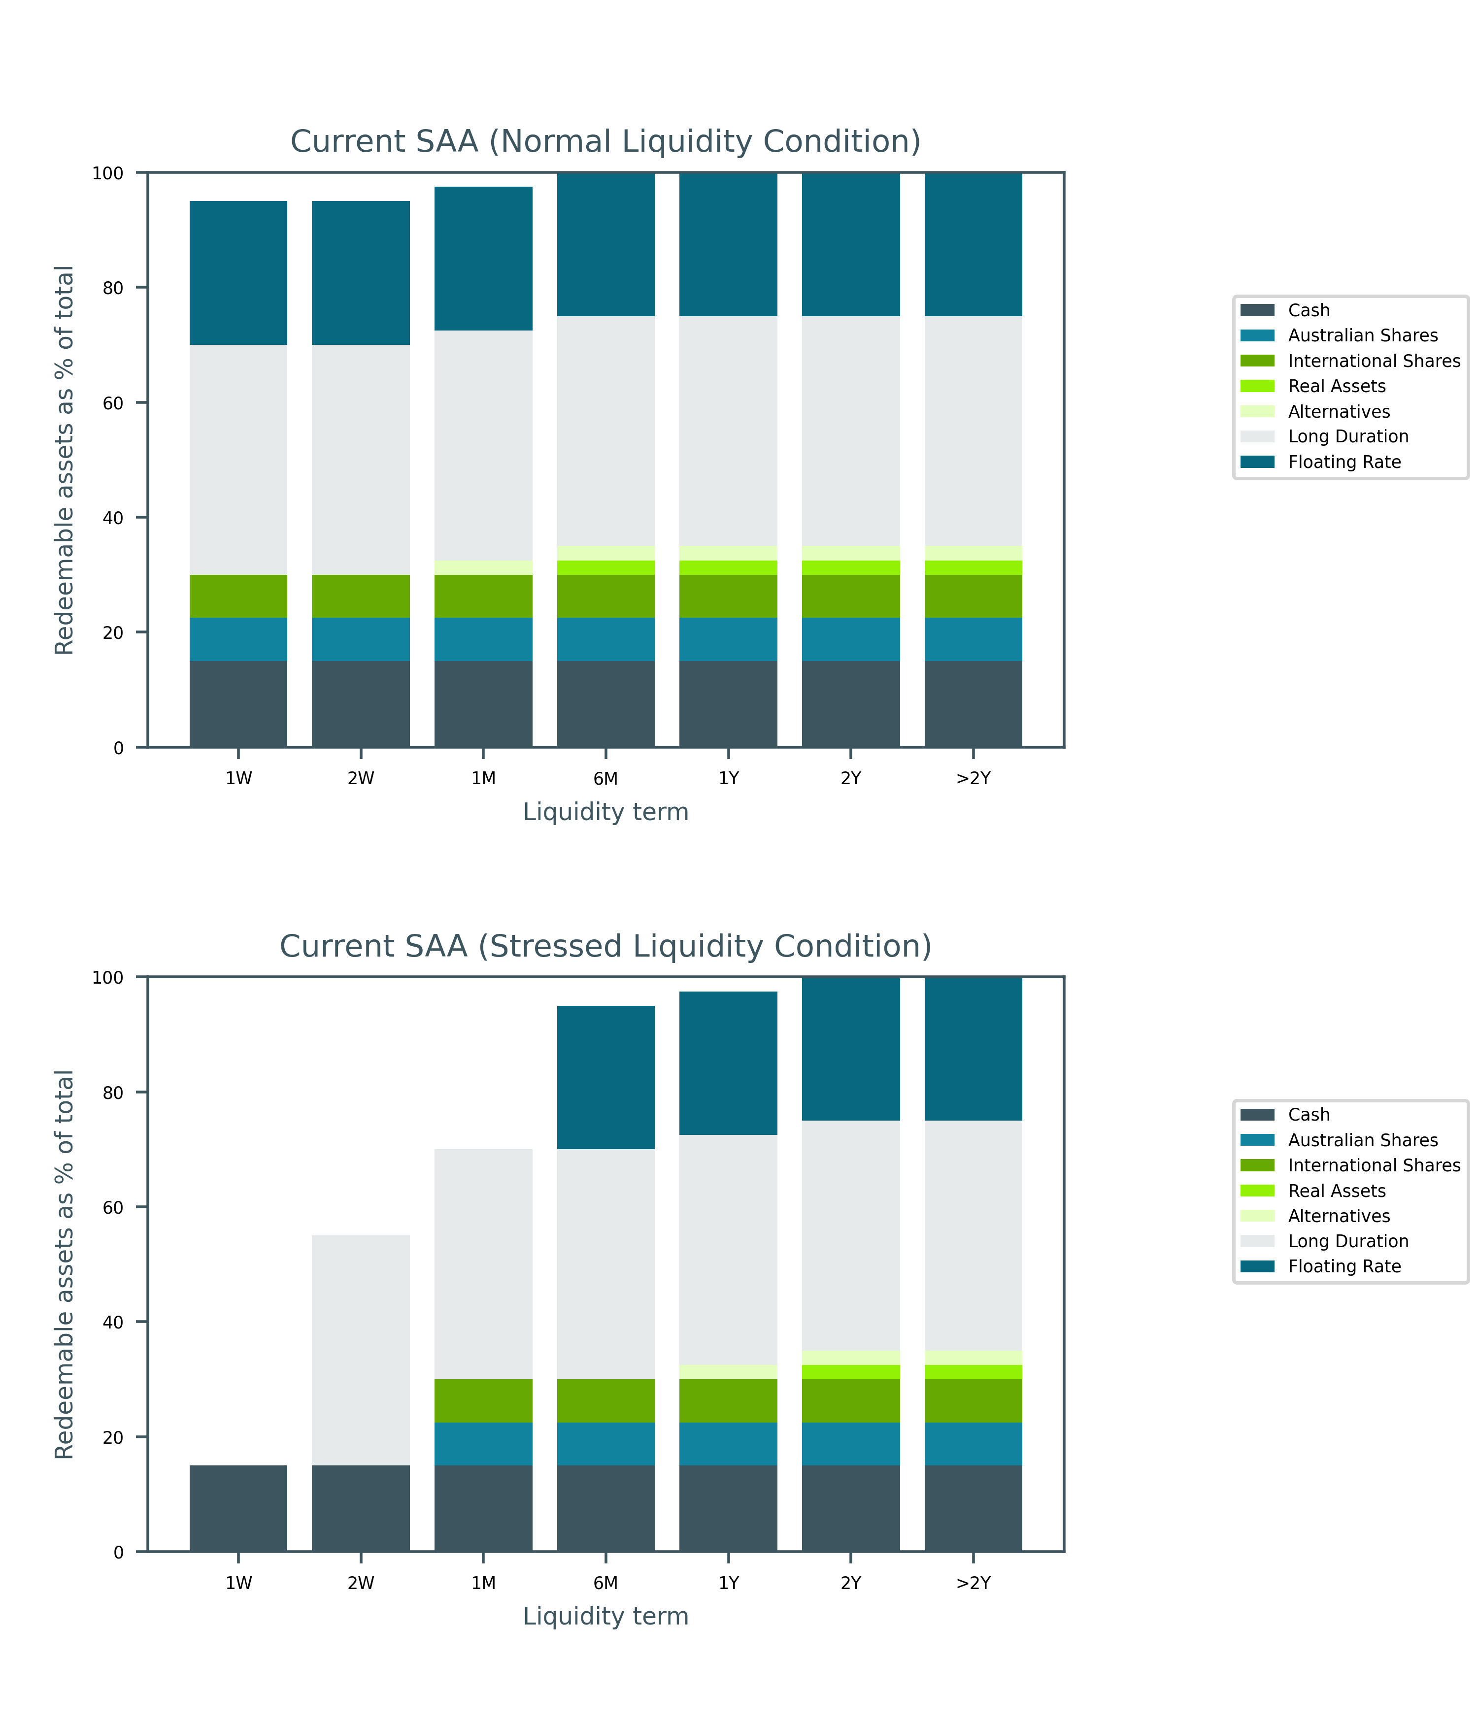

Atchison Active 40

Table 41: Liquidity in days for investment strategy

|  |  |  |
| --- | --- | --- |
| Portfolios | Normal Liquidity (Days) | Stressed Liquidity (Days) |
| Atchison Active 40 Current SAA | 9.6 | 62.7 |
| Atchison Active 40 P1 | 13.7 | 87.6 |
| Atchison Active 40 P2 | 5.3 | 43.8 |

* Under normal market conditions, on weighted average basis, the recommended strategy is invested 100% in assets with 9.6 days or less liquidity.
* Under stressed market conditions, on weighted average basis, the recommended strategy is invested 100% in assets with 62.7 days or less liquidity.

Figure 8 below shows percentage of assets by asset class, that are liquid illustrated over various time horizons.

* The expected time to liquidate 100% assets for the current SAA is over 2 years under normal market condition but over 2 years under stressed market condition.

Figure 8: Liquidity Profiles of Atchison Active 40

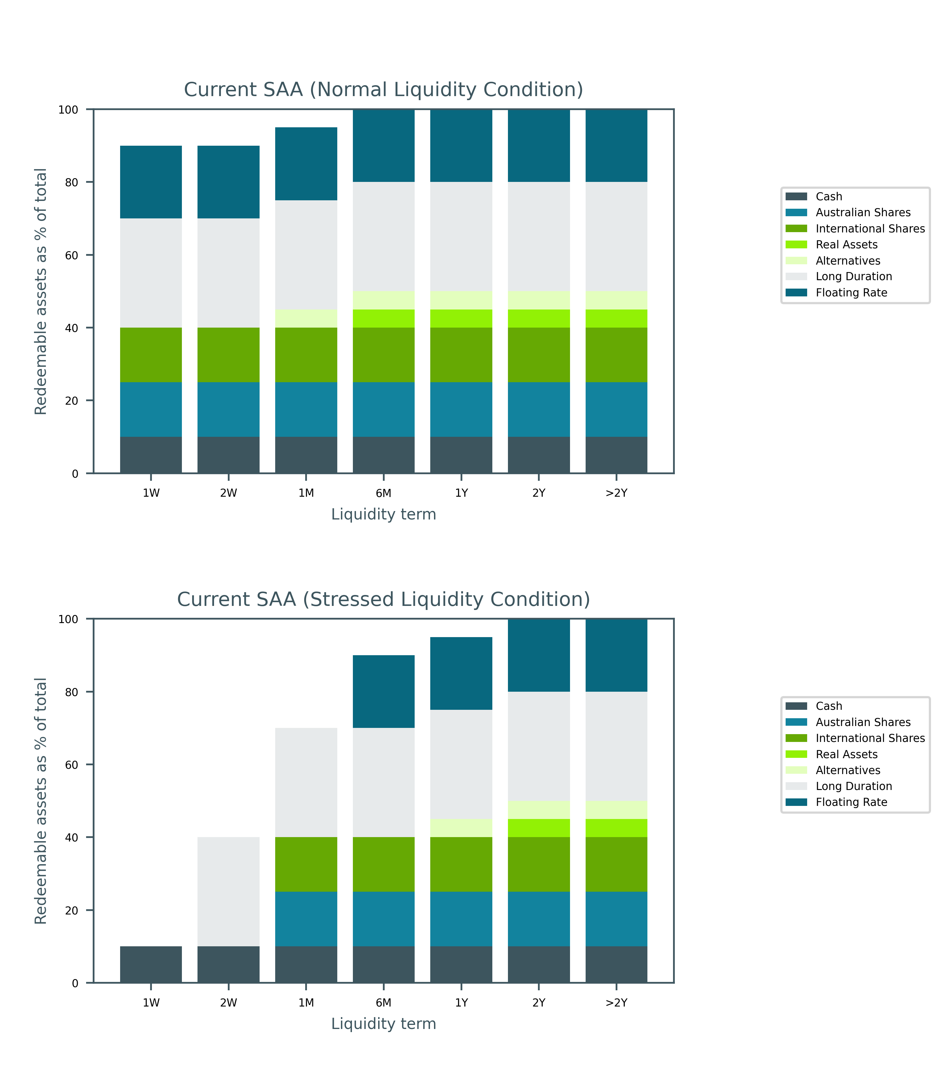

Atchison Active 55

Table 42: Liquidity in days for investment strategy

|  |  |  |
| --- | --- | --- |
| Portfolios | Normal Liquidity (Days) | Stressed Liquidity (Days) |
| Atchison Active 55 Current SAA | 14.8 | 96.9 |
| Atchison Active 55 P1 | 13.5 | 88.8 |
| Atchison Active 55 P2 | 6.1 | 54.0 |

* Under normal market conditions, on weighted average basis, the recommended strategy is invested 100% in assets with 14.8 days or less liquidity.
* Under stressed market conditions, on weighted average basis, the recommended strategy is invested 100% in assets with 96.9 days or less liquidity.

Figure 9 below shows percentage of assets by asset class, that are liquid illustrated over various time horizons.

* The expected time to liquidate 100% assets for the current SAA is over 2 years under normal market condition but over 2 years under stressed market condition.

Figure 9: Liquidity Profiles of Atchison Active 55

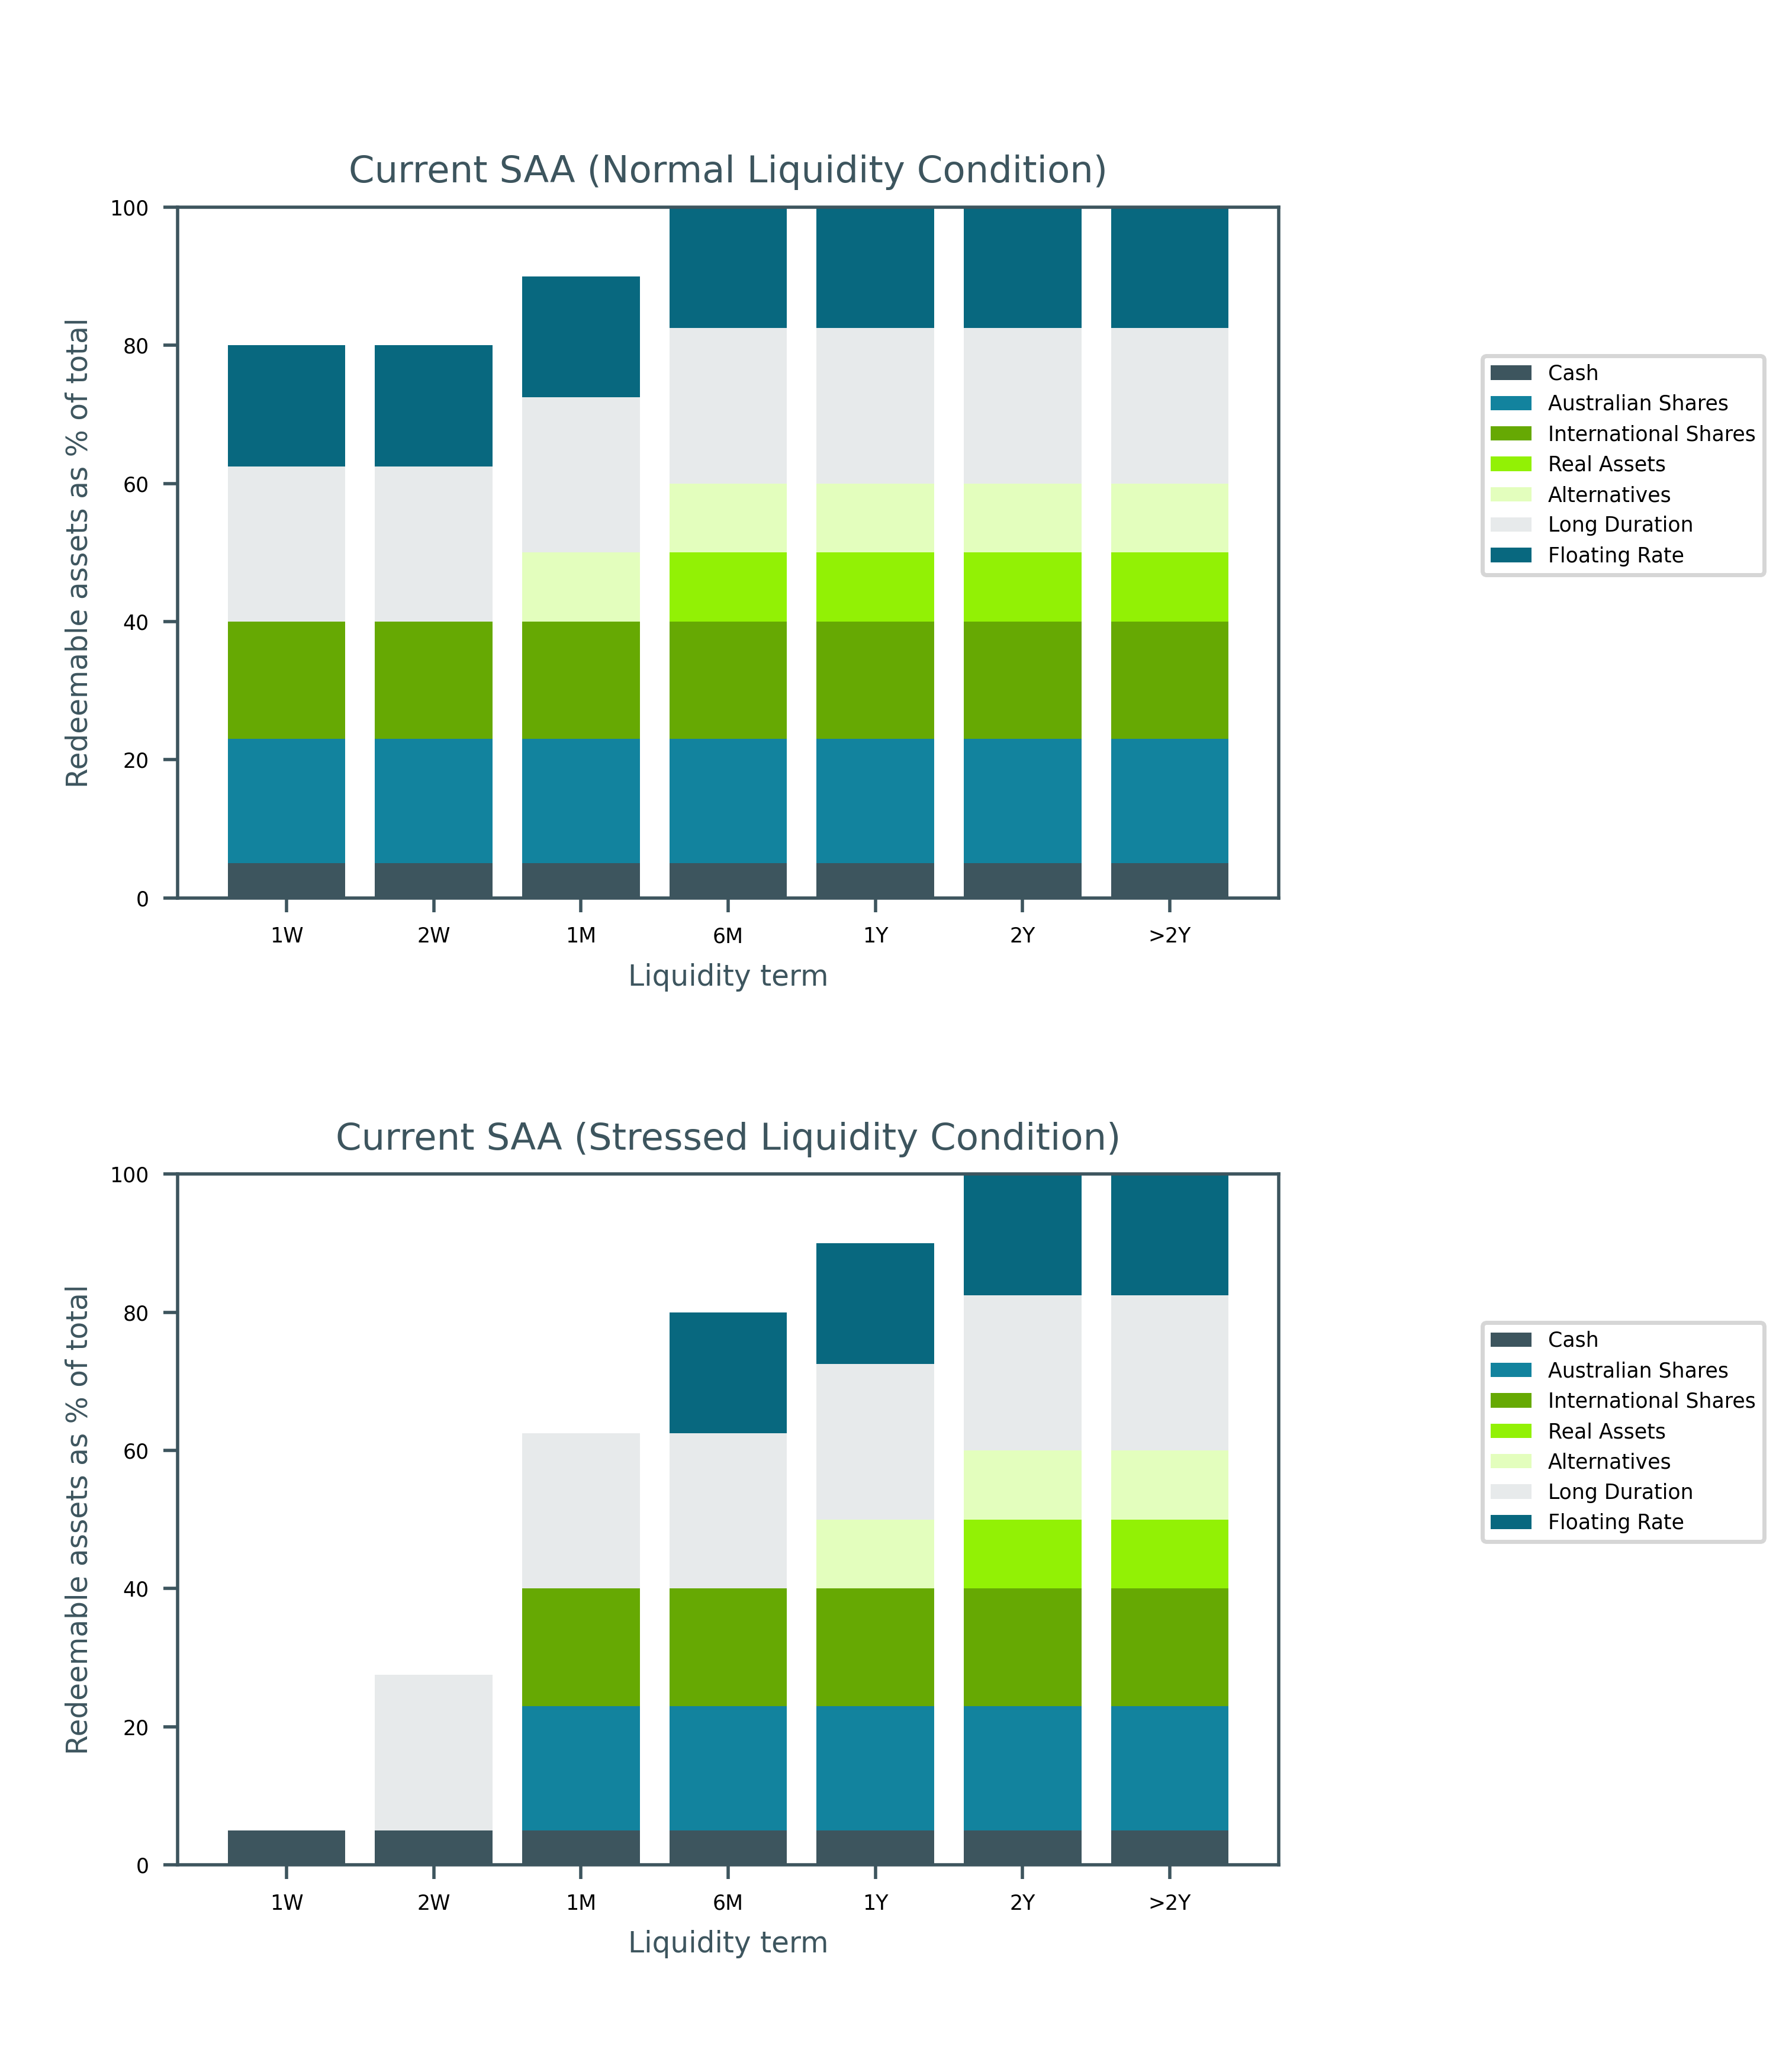

Atchison Active 70

Table 43: Liquidity in days for investment strategy

|  |  |  |
| --- | --- | --- |
| Portfolios | Normal Liquidity (Days) | Stressed Liquidity (Days) |
| Atchison Active 70 Current SAA | 17.3 | 112.1 |
| Atchison Active 70 P1 | 19.1 | 122.3 |
| Atchison Active 70 P2 | 15.2 | 99.8 |

* Under normal market conditions, on weighted average basis, the recommended strategy is invested 100% in assets with 17.3 days or less liquidity.
* Under stressed market conditions, on weighted average basis, the recommended strategy is invested 100% in assets with 112.1 days or less liquidity.

Figure 10 below shows percentage of assets by asset class, that are liquid illustrated over various time horizons.

* The expected time to liquidate 100% assets for the current SAA is over 2 years under normal market condition but over 2 years under stressed market condition.

Figure 10: Liquidity Profiles of Atchison Active 70

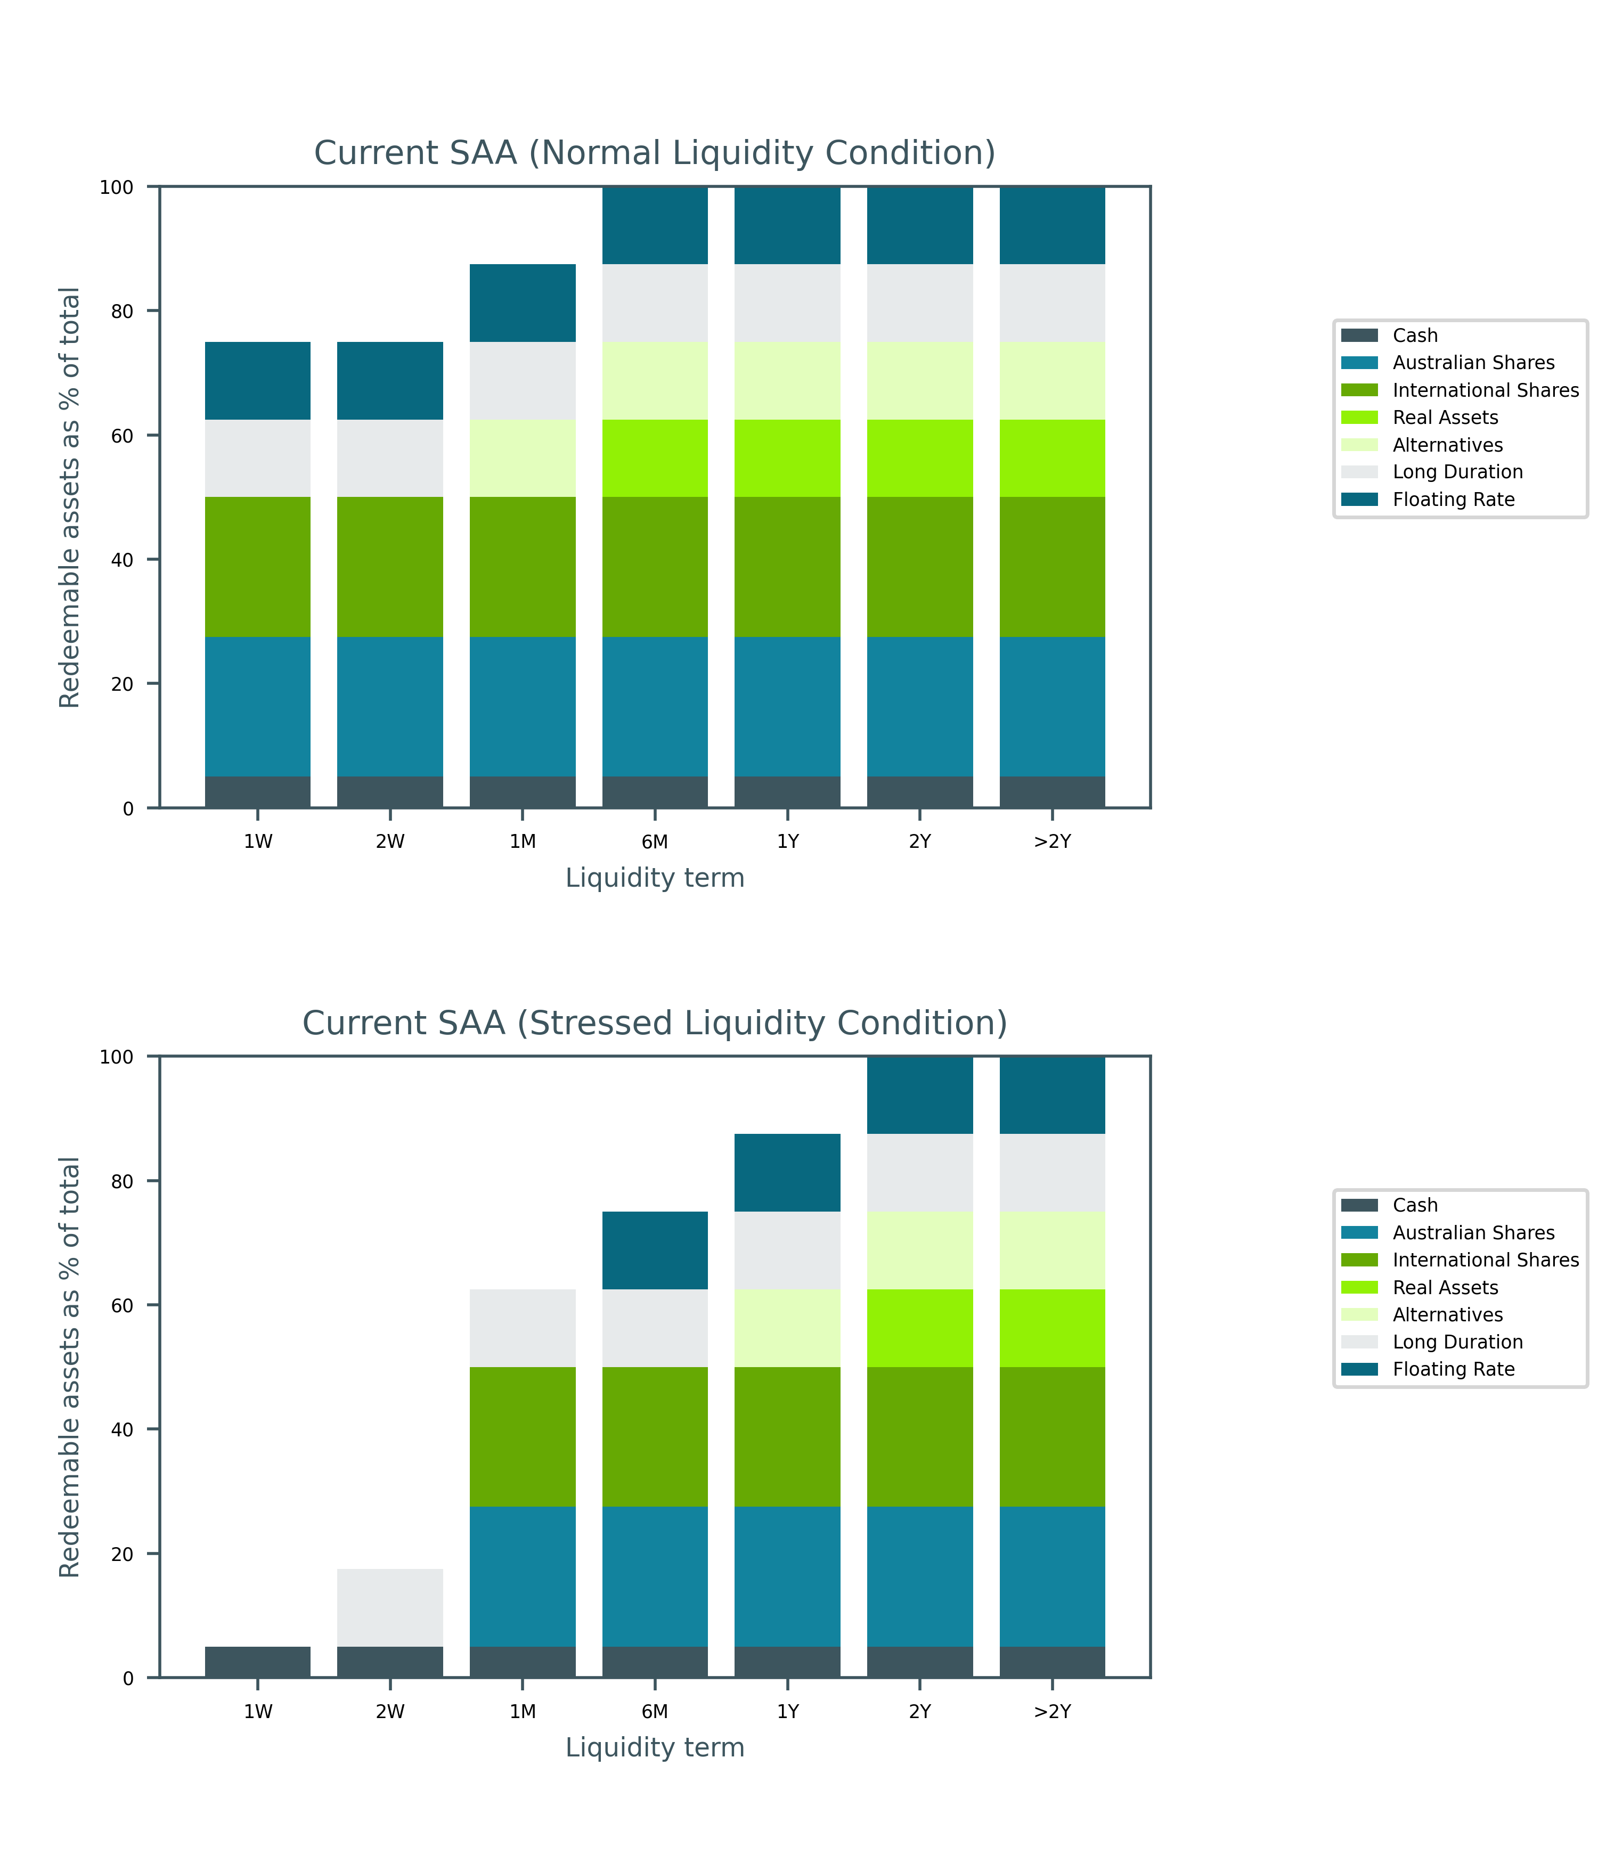

Atchison Active 85

Table 44: Liquidity in days for investment strategy

|  |  |  |
| --- | --- | --- |
| Portfolios | Normal Liquidity (Days) | Stressed Liquidity (Days) |
| Atchison Active 85 Current SAA | 13.2 | 92.4 |
| Atchison Active 85 P1 | 12.9 | 78.9 |
| Atchison Active 85 P2 | 7.3 | 76.8 |

* Under normal market conditions, on weighted average basis, the recommended strategy is invested 100% in assets with 13.2 days or less liquidity.
* Under stressed market conditions, on weighted average basis, the recommended strategy is invested 100% in assets with 92.4 days or less liquidity.

Figure 11 below shows percentage of assets by asset class, that are liquid illustrated over various time horizons.

* The expected time to liquidate 100% assets for the current SAA is over 2 years under normal market condition but over 2 years under stressed market condition.

Figure 11: Liquidity Profiles of Atchison Active 85

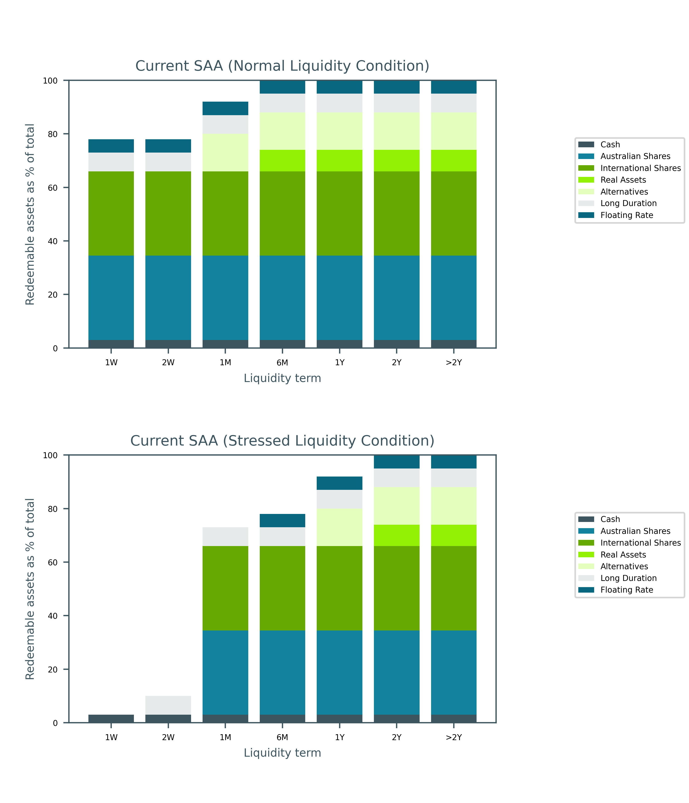

Atchison Active 100

Table 45: Liquidity in days for investment strategy

|  |  |  |
| --- | --- | --- |
| Portfolios | Normal Liquidity (Days) | Stressed Liquidity (Days) |
| Atchison Active 100 Current SAA | 9.5 | 75.3 |
| Atchison Active 100 P1 | 12.7 | 73.1 |
| Atchison Active 100 P2 | 7.8 | 80.1 |

* Under normal market conditions, on weighted average basis, the recommended strategy is invested 100% in assets with 9.5 days or less liquidity.
* Under stressed market conditions, on weighted average basis, the recommended strategy is invested 100% in assets with 75.3 days or less liquidity.

Figure 12 below shows percentage of assets by asset class, that are liquid illustrated over various time horizons.

* The expected time to liquidate 100% assets for the current SAA is over 2 years under normal market condition but over 2 years under stressed market condition.

Figure 12: Liquidity Profiles of Atchison Active 100

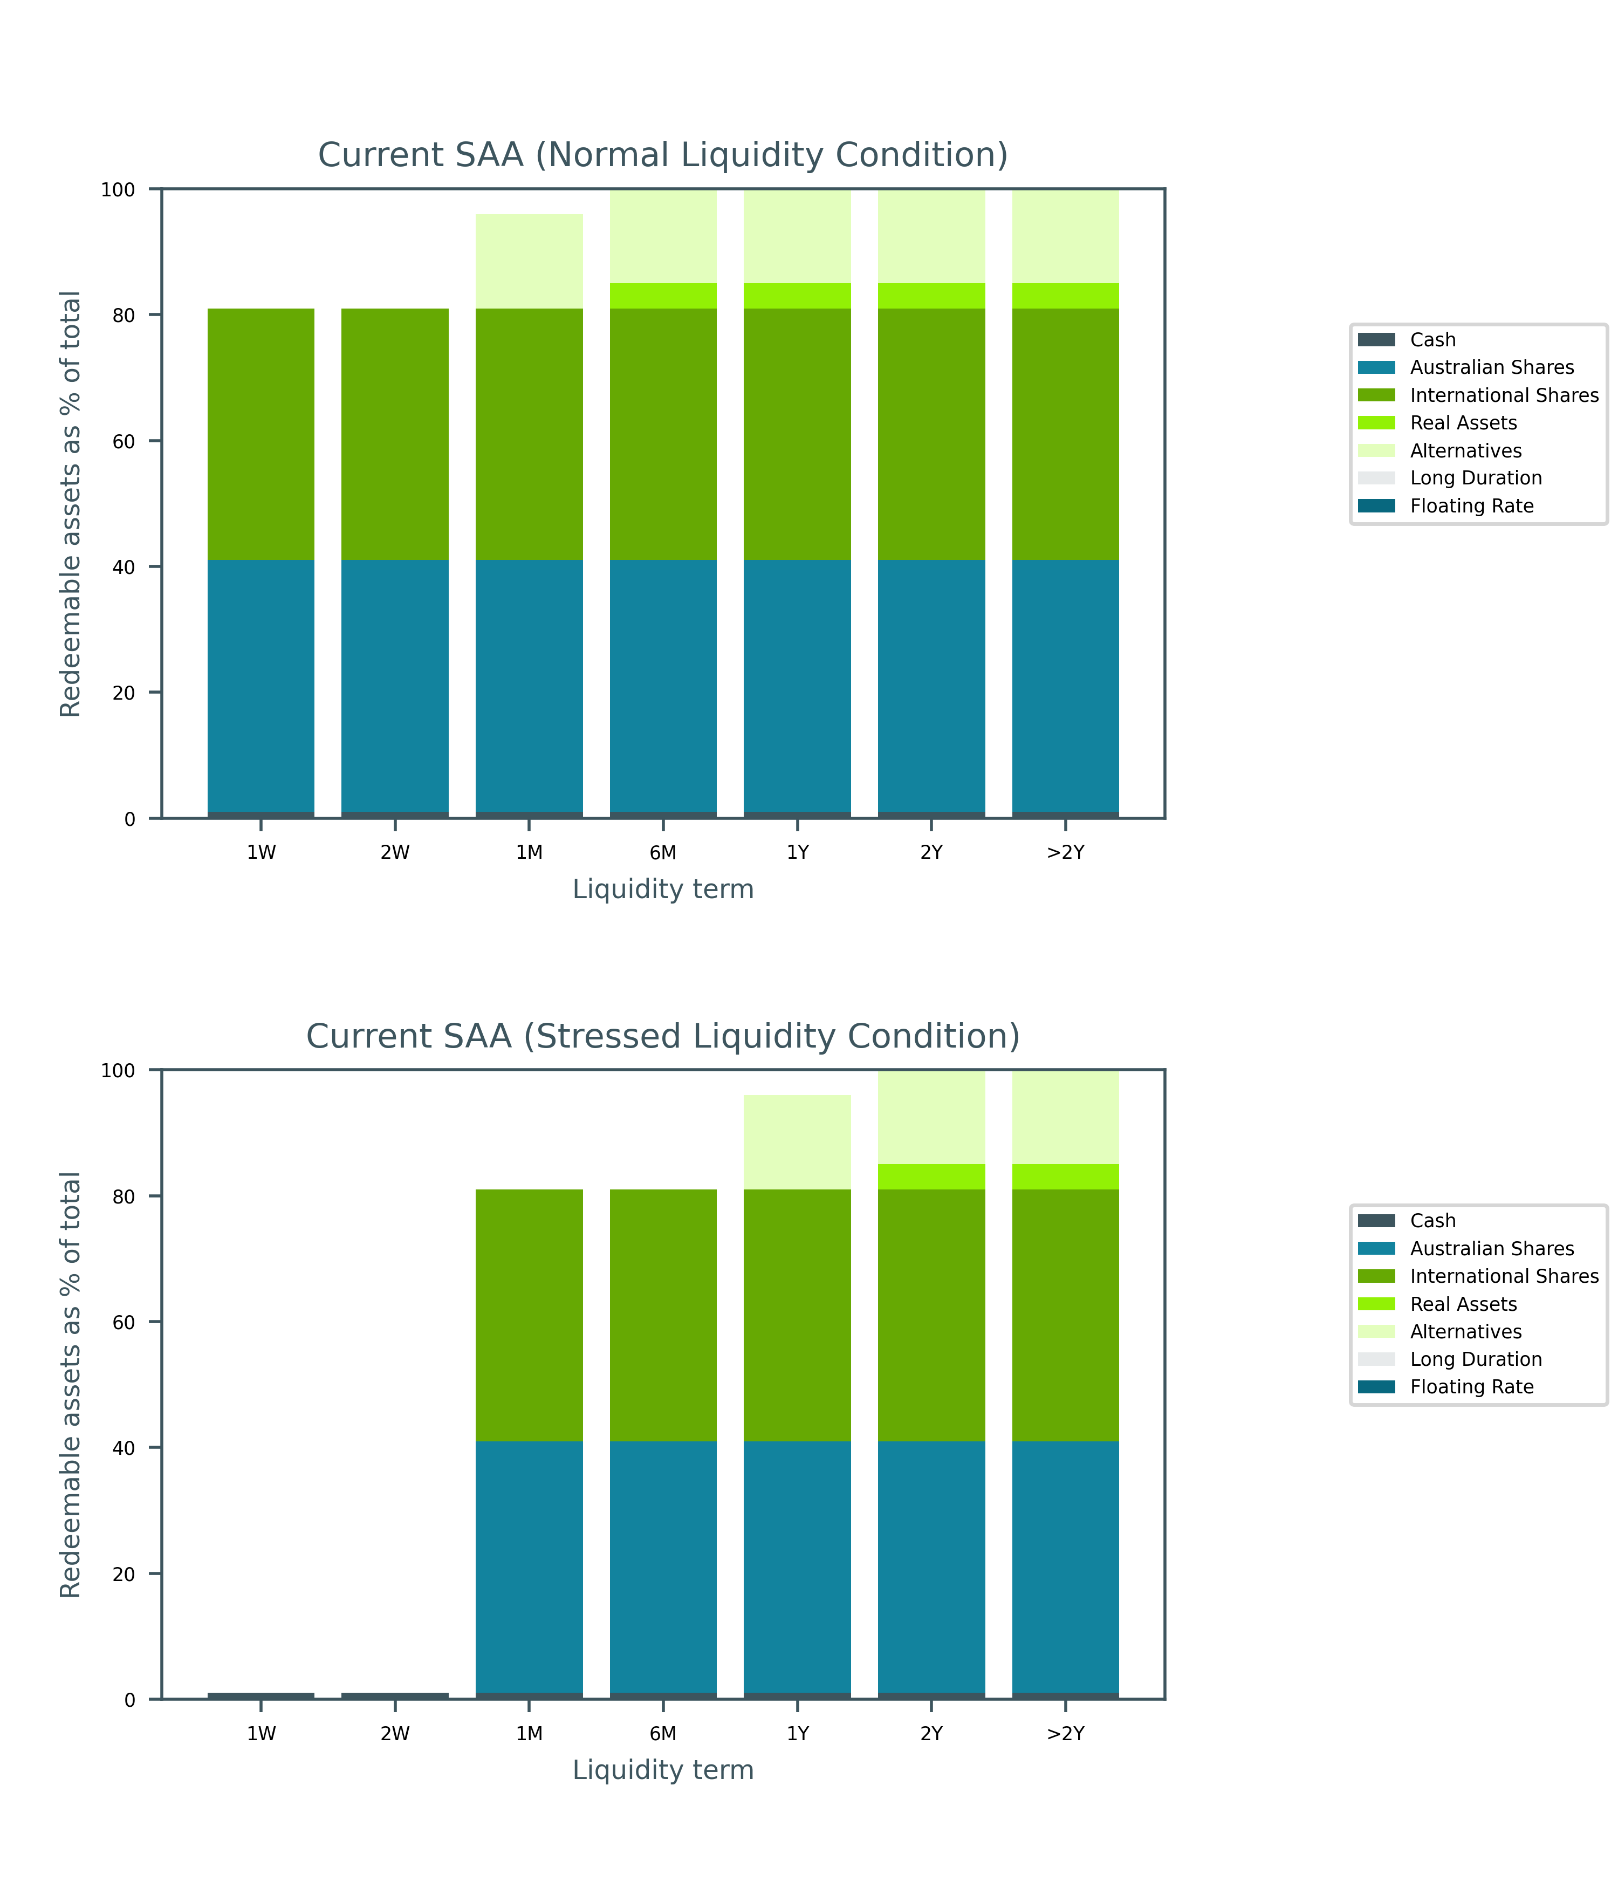

The liquidity analysis was performed across the asset allocations under various liquidity conditions:

* Extreme market conditions would deteriorate the liquidity expectation leading to longer period for Atchison to liquidate 100% of the assets.

## Liquidity Risk Management

The Atchison Administrator reports contribution flows and member exits/outflows to the Trustee and investment manager to assist in the early identification of unusual patterns.

In managing liquidity risk the following matters may be included:

* Cash flow projections and past cash flow will be prepared on a regular basis to check the liquidity level needed
* Whether there are appropriate early warning indicators of liquidity risk for the single investment of the Atchison, and
* Reporting to the Research and Investment Team, Trustee Investment Committee and Board.

### Conclusion

Consideration has been given to the liquidity of the underlying investments in stressed market conditions for Atchison. All strategies are expected to remain liquid under stressed market scenarios.

### Recommendation

It is recommended that cash flow requirements are closely monitored to ensure sufficient cash is available to meet liabilities as they arise.